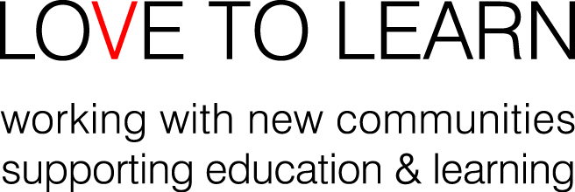

POLICY ON GIFTS TO STAFF AND VOLUNTEERS

Aim
The aim of this policy is to make clear Love to Learn’s policy on gifts to staff and volunteers and how this policy is to be managed and explained.

Policy Statement
Love to Learn recognises that ‘giving back’ something to staff or a volunteer who has provided support is sometimes a way in which a service user can feel more empowered and less ingratiated. It is understandable that some service users or their family may wish to thank staff or volunteers with whom they have developed a close working relationship. Furthermore, refusal of a gift may cause offence.
However, Love to Learn does not wish to encourage service users to give gifts as this can place an employee or volunteer in a position where suggestions or allegations of undue influence, impropriety or special attention could be made. In addition, vulnerable people without resources might feel under pressure to give gifts if they see others giving. For these reasons, we cannot allow staff or volunteers to accept gifts from service users, service users’ relatives or external agencies or bodies except in circumstances as outlined below. All gifts must be declared to Love to Learn’s Co-ordinator and she can give advice on how to interpret this policy. Greeting cards are not included as ‘gifts’.

Gifts from Service Users or their Relatives
Hospitality
Hospitality during a home visit – many families will provide drinks and food to staff and volunteers when they visit them at home. All staff and volunteers are welcome to eat and drink with families in their homes if they wish. If a meeting is held in a café and refreshments are brought, staff or volunteers should pay, keep the receipt, and claim this as expenses.
Small gifts
If a service user offers staff or volunteer a very small gift, e.g. chocolate or token worth less than £10, staff should politely decline, explain that Love to Learn has a gift policy which means that they can’t accept the gift. If the service user is insistent or staff feel it would cause offence to refuse, staff should explain that they will take the gift back to the office to share with the whole team, but ensure that the service user knows that they would not be able to accept anything else. Staff/volunteers should explain that service users can donate to the organisation as a whole if they wish, but do not need to do so as all our services are free. Any small gift excepted in this way should be reported to the Love to Learn Co-ordinator straight away.
Gifts to the whole office or for service users or young people
If service users wish to contribute homemade gifts of food to the office or people using services, they are welcome to do so, but should be discouraged from doing this very regularly unless we are able to pay them for ingredients.

Cash gifts or gift vouchers
Staff or volunteers should never accept cash gifts or gift vouchers (regardless of value). They should politely thank the service user, but explain clearly that they are not allowed to accept the gift. If the service user wishes to make a donation to Love to Learn, they are welcome to do so. If staff or volunteers do not realise that an envelope contains cash or a voucher, they should return the gift as soon as possible (or pass it to Love to Learn’s Director, who will return it to the family with a polite explanation). Staff or volunteers should always report any cash/voucher gifts to Love to Learn’s Co-ordinator (regardless of whether they were accepted or refused).
Avoiding causing offence
Refusing a gift from a service user may be difficult and embarrassing and staff and volunteers may be worried about causing offence. If it is helpful, they can accept the gift and then give it to the Love to Learn Co-ordinator who can ensure that it is returned to the family in a polite way and explain our policy to them.

Gifts from External Agencies or Companies
Any gifts from external agencies or companies should be declared to your line manager and donated to the office. They may be accepted if they are small gifts, under £10, e.g. chocolates or a diary. If they are substantial, they must be returned.
Giving gifts
Apart from Love to Learn educational resources or equipment, it is not appropriate for staff or volunteers to give personal gifts to service users. Love to Learn resources can be labelled with our details (even if we do not require them to be returned) in order to demonstrate that they are not gifts.

Relationship with other Procedures
Deliberate failure to abide by this policy may warrant disciplinary action or the reviewing of a volunteering relationship.

STATEMENT FOR PARENTS AND SERVICE USERS

Dear parents,
Please note:
All our services are FREE. We do not charge or accept any money for any of our services.
Our staff and volunteers are not allowed to accept any gifts from people using our services.
There are many ways in which you can contribute to our organisation if you would like to – please speak to a member of staff.
Many thanks! LOVE TO LEARN

