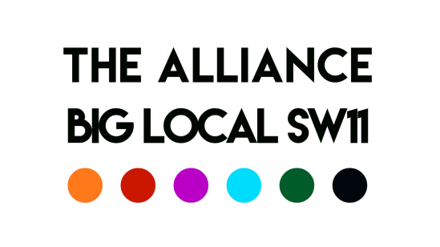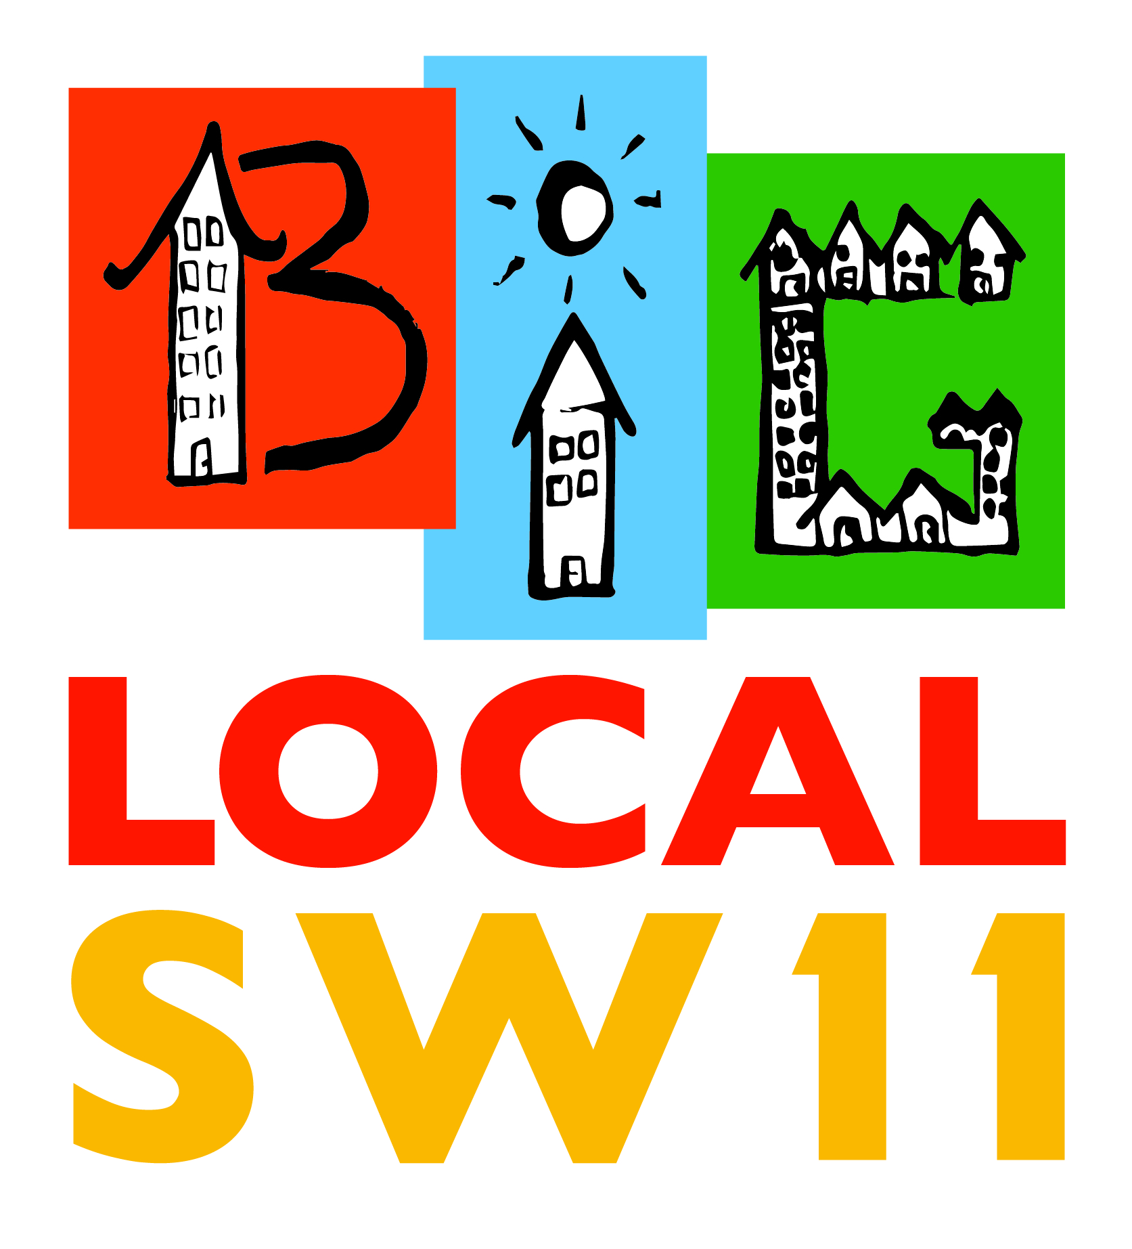

## Covid 19 Battersea Community Support Fund - Application Form

This fund is designed to help **local organisations** to support people in Battersea, particularly the most vulnerable, to cope with the challenges of Covid-19.

|  |  |  |
| --- | --- | --- |
| Your Contact Details | Responses | Official |
| Name  Organisation  Address  Telephone:  Email:  Web: |  |  |
| Funding Applied For (£) |  |  |
| How this will be used to  Support People in Battersea: Please provide as much detail as possible.  Example:  “Paying for fuel costs to deliver food from X to Y”  “Covering the out-of-pocket expenses of 10 volunteers for X hours/days”. |  |  |
| Monitoring Data  Number of volunteers  Number of Beneficiaries | To be provided at completion of the project |  |
| Submission | Email: [david@biglocalsw11.co.uk](mailto:david@biglocalsw11.co.uk) please put **Covid-19** in the Subject line |  |
| Decision | The awards panel will meet weekly and you should be notified of the outcome within 5 working days but sooner in urgent cases |  |
|  | | |

## Conditions

|  |
| --- |
| The funds will apply for the duration of Covid-19 and will cease on the official declaration of its ending or as soon as reasonable thereafter.  GDPR By signing this form you consent for your contact information to be used by the BLSW11 Alliance for communications and research purposes.  However please advise us if you do not wish to receive further communications from us.  It is not a condition but would be a courtesy if BLSW11 Alliance were acknowledged as your project supporter.  If your application is successful we will require your organisation’s Bank Details payments by BACS |

|  |  |
| --- | --- |
| Eligibility Criteria – For Guidance Only The Following are examples of what may be funded but other uses may be considered on a case-by-case basis:  Volunteer Costs   * Out of pocket expenses * Protective equipment * Training * DBS Checks   Transport   * Fuel * Fares * Hire   Equipment   * Printing * Security * Physical Aids * Hire * IT equipment including smart phones/devices   Supplies   * Food * Hand Washers * Bacterial Wipes * IT Support | Not Eligible The Following will not be funded:   * Projects that are political or religious * Projects that should be delivered by statutory services * Payments to individuals other than through a recognised organisation * Projects that were running before Covid-19 |