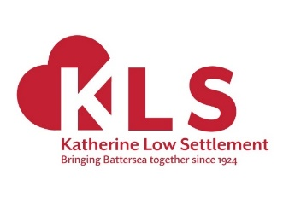

**Katherine Low Settlement’s Love to Learn GCSE Study Group**

**Annual Monitoring Report**

**November 2019 - December 2020**

03Dec20

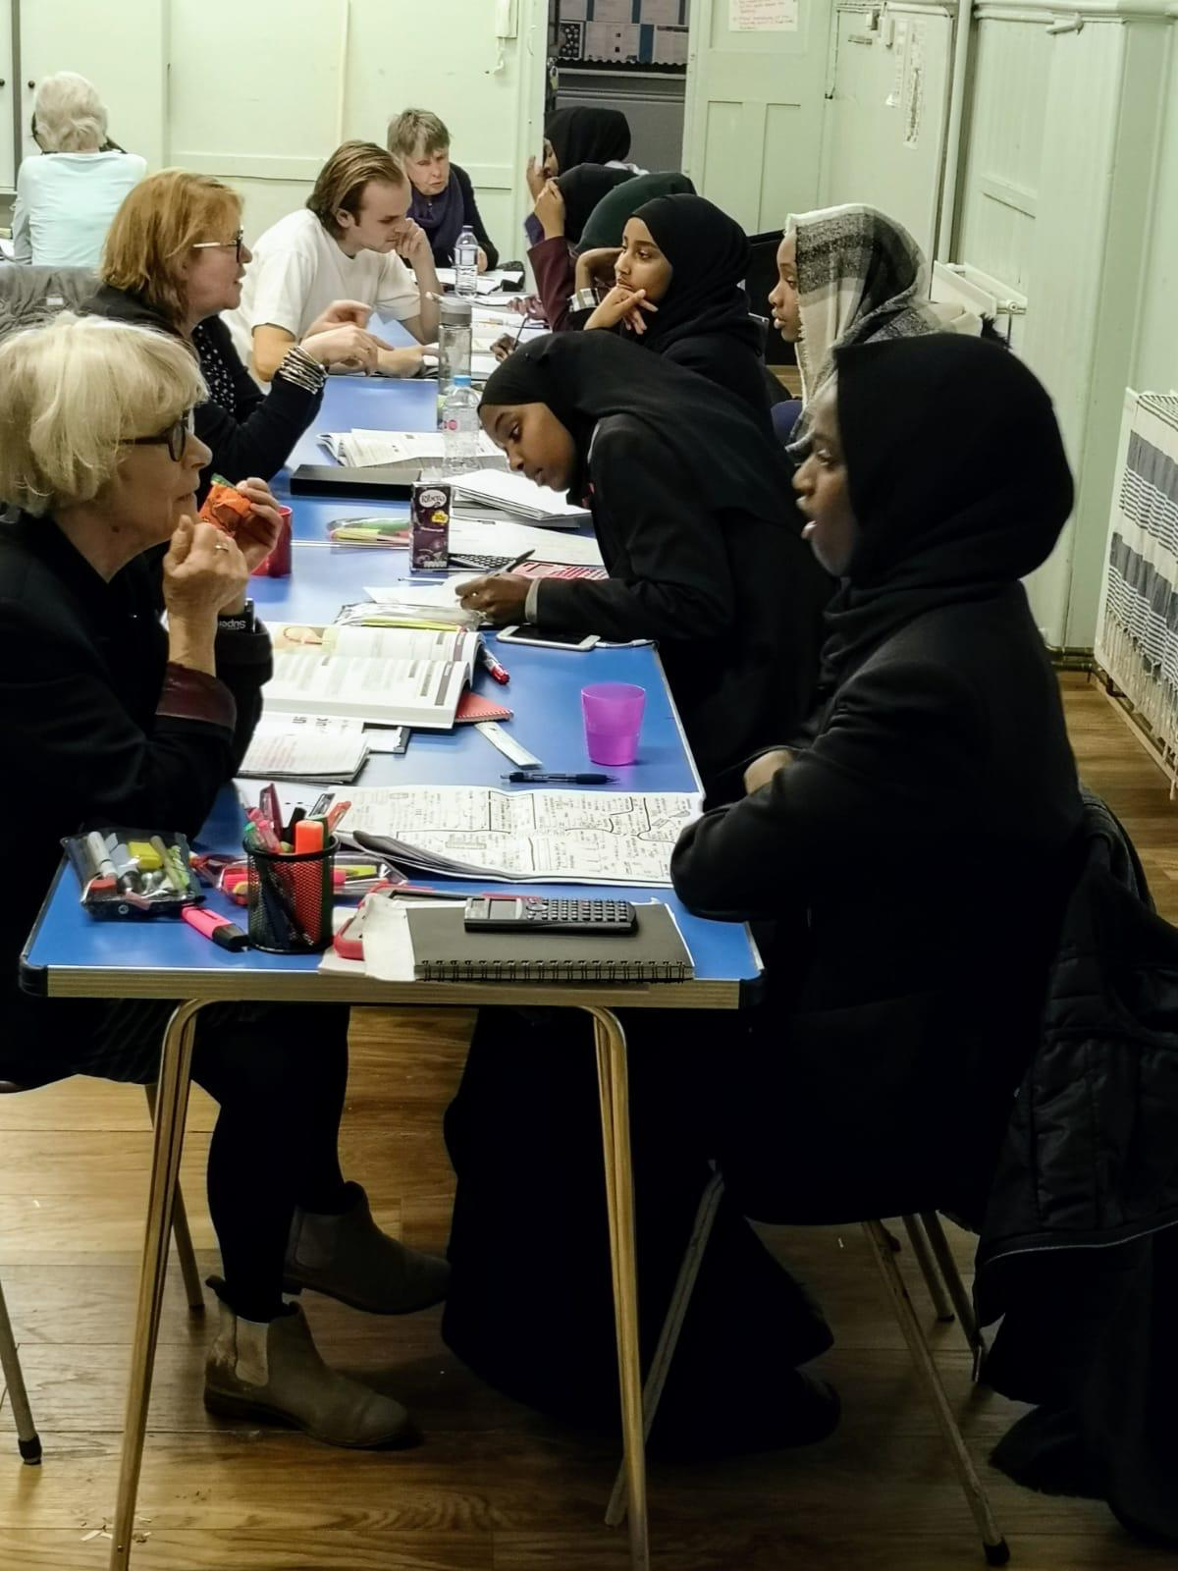

*Volunteer learning mentors providing one-to-one support at KLS’ GCSE Study Group*

Paula Robertson 020 7585 0399

Head of Love to Learn [paula@love-to-learn.org.uk](mailto:paula@love-to-learn.org.uk)

Katherine Low Settlement [www.klsettlement.org.uk](http://www.klsettlement.org.uk)

*Katherine Low Settlement Ltd is a registered charity no. 1081248, and a company limited by guarantee no. 3814833*

1. **Summary**

This is a short report summarising the work of KLS’ Love to Learn’s GCSE Study Group over the last year.

1. **About Katherine Low Settlement**

Katherine Low Settlement (KLS) is a charity that has been serving Battersea and the wider Wandsworth community since 1924. We are dedicated to building stronger communities and enable people to challenge and find ways out of poverty and isolation.

We run a range of our own community projects to support children, young people and their families, older people and refugee communities. We recognise there are many other expert local charities and community groups working with, for example, disabled people and mental health users. We invite them to operate from our premises – so together as partners we can meet the diverse needs of the local communities of Wandsworth. We work with 45+ charities and community groups supporting more than 1,100 people each week. Visit: [www.klsettlement.org.uk](http://www.klsettlement.org.uk)

1. **About KLS’ Love to Learn education programme**

KLS’s Love to Learn education programme makes a real difference to the lives of young people from refugee backgrounds in Battersea and the wider Wandsworth community, by broadening their educational experiences, improving educational outcomes and confidence, and supporting their aspirations.

Who we work withyoung people from refugee backgrounds who:

1. Are approaching tests, exams and school transition. With support they achieve good levels which enable them to progress further in their goals and aspirations.
2. Require educational help due to language, lack of print literacy, disrupted education (both pre- and post-migration), or other additional needs such as Special Education Needs.
3. Have recently arrived in the UK, particularly if unaccompanied minors or joining family after separation.
4. Live in areas of deprivation in London Borough of Wandsworth (principally from Battersea communities).

We provide a range of educational services and support including advocacy and advice, homework support through learning mentors and clubs, parent workshops and supported referrals. We liaise with schools, social services, other community organisations and service providers to ensure that families access appropriate and targeted support for their needs.

1. **Background to KLS’ Love to Learn GCSE Study Group**

We know from our hands-on experience and local research that there is a tremendous need within local refugee communities for additional support for young people studying for their GCSE exams. This can be for any number of reasons: low levels of English within the family; interrupted schooling in the home country; traumatic experiences before arrival; lack of home learning support; parents not understanding how the UK education system works and how to support their children’s education, children's’ lack of confidence; racism, bullying and stereotyping (increased by anti-immigration climate); limited experiences outside school/home; lack of aspiration; and Special Education Needs not being addressed.

We have been running popular Homework & Activity Clubs since 2005, for refugee children aged 5 to 14 (school years 1 to 9), during term-time and the holidays. We always felt there was a need for a specific group for those studying for their GCSE exams in Years 10 and 11. We also received requests on a monthly basis from young people and their families asking for this type of support.

After some discussion with the young people, they told us that they would feel most comfortable in a female-only environment, as we already had a successful boy’s GCSE Study Group running. The girls-only Study Group was trialed with a small group of 9 girls in 2017/18. It was extremely successful and popular. We decided to roll this out to meet the demand.

The GCSE Study Group grew quickly with 22 young people attending each week in 2018/19. Due to demand we decided to add a second mixed group of boys and girls. This group enables under-achievers with high potential to boost their learning in the run up to their GCSE exams in Year 10, 11, 12 & 13 (14-18 years old). The GCSE Study Groups focus on key core subjects: English, Maths and the Sciences.

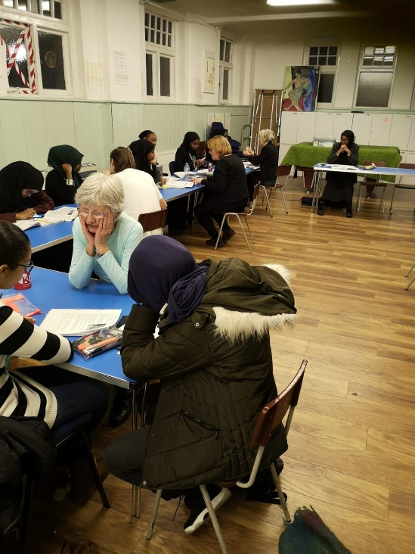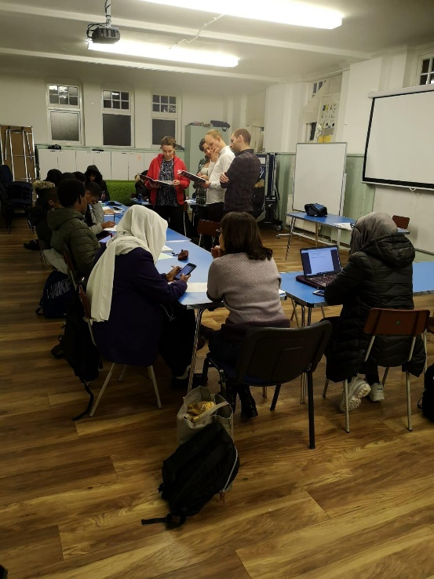

*Learning together*

1. **Attendance & Retention**

We now run two 1.5-hour revision GCSE Study Groups, each week during term time, and one full day of revision support during the school holidays. 43 young people attend the study sessions. There is a high retention rate and very good attendance: on average between 28 and 32 students attend each week. Please note, that these numbers relate to pre-lockdown.

1. **Staff Recruitment and Volunteers**

In December 2018 we recruited a paid member of staff (Abdul Chowdry) to plan and run the GCSE Study Groups. Abdul is a local retired teacher. He has over 40 years of teaching experience with Maths and other subjects in local secondary schools. He was also the Head of Department in a number of schools, and a foster carer for young people for over 28 years.

We have 9 volunteers that attend each week to support the refugee young people. They are from a variety of professional backgrounds including retired teachers, postgraduate students, three current secondary teachers, a social worker and two people working in business. They act as ‘teaching assistants’ in the classroom, providing one-to-one support as needed.

1. **Outcomes**

The GCSE Study Groups strive to achieve the following outcomes for the students:

**i. Improve learning skills:** All those that attended the GCSE Club said that their learning skills had improved as a result of attending the group. In particular, having help from an adult, the use of revision books and access to computers and the internet.

**ii. Improve their confidence, self-esteem and motivation:** When a young person joins the study group for the first time, Abdul meets with them and their parent/carer. This gives him the opportunity to find out how the young person is doing at school, what they would like support with, and how they are generally. It is crucial for us that the Study Group is a safe and caring place for all that attend. We train all staff and volunteers in increasing confidence and safeguarding. We aim to provide specific positive feedback and ensure they are all listened to, feel valued and receive positive and constructive praise.

35 out of 43 young people attending said that they felt more confident about their exams. All 43 said they felt more confident about their studies in general as a result of attending the GCSE Study Group.

Volunteers have observed a real increase in confidence in all the young people that attend the group. One of our volunteers, Anne, a secondary English teacher, has been volunteering with the Group for two years. She told Abdul, our Project Worker, how impressed she has been with how quickly the young people feel part of the group. *"Many of the girls that come are extremely shy and reserved when they start, after just two or three sessions they relax and start to trust us and ask questions. I have seen the young people I have worked with really blossom and relax in the environment... They take ownership of the space and know they can come to us if they are struggling with something from school that week".*

Halima is in Year 12 and has attended the Club from Year 10 and told us, *"The teachers were really supportive and good… I suffered bullying at secondary school, and everybody here has helped me grow in confidence and be stronger in myself".*

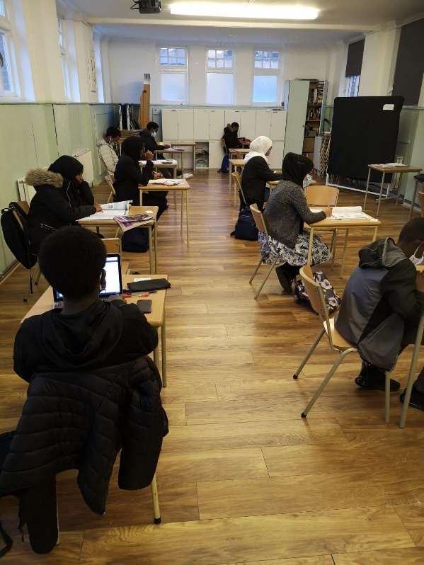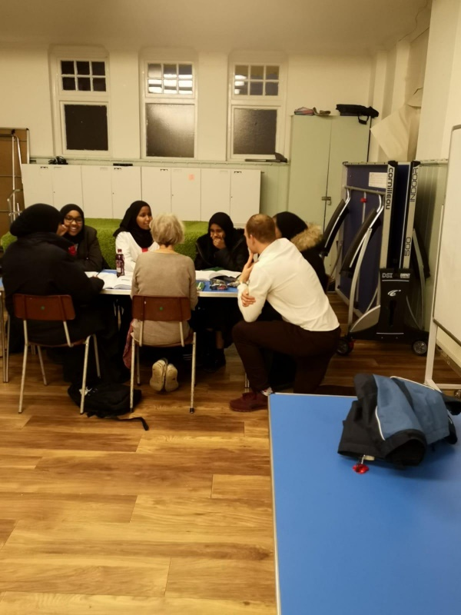

*The benefits of working individually and in small groups*

1. **On-going support during Lockdown**

As we went into the first lockdown in March’20 we moved the GCSE Study Group online, using WhatsApp and Zoom. We offered additional support over the phone. We also sent learning packs through the post, which included new revision books covering Maths, Science and English and study materials.

All of the young people that attend the Study Groups come from refugee families living on very low incomes, and in poverty. They experienced a lot of financial hardship during lockdown. For us to provide this extra support during this challenge time was a lifeline for our young people and helped them continue their studies.

The GCSE club has grown in popularity and each academic year young people attend that we have never worked with before. In fact, 13 students that joined the group this term are new to Love to Learn. They found out about the Study Group through ‘word of mouth’ and school referrals. This gives our team the opportunity to work with new families and support them in other ways as needed.

Having built trust with families and young people, we are inevitably approached about other issues (which also impact on children/young people thriving in school) including Special Educational Needs (SEN), poverty, benefits and housing issues. As a result, seven families of the young people attending have been referred to our other advice and advocacy team at Love to Learn and outside advice agencies like Citizens Advice Wandsworth.

Covid-19 has exposed a digital divide in the local community. This has been particularly prevalent with the refugee families we work with. During the first lockdown we found young people and their families were feeling isolated. With schools closed and pupils having to study at home, the inability of our poorest students to access technology meant they are unable to access the resources and work being set by their schools, as well as stay in touch with friends and family. We worked hard to get laptops to all the young people in need. Ten GCSE club students were given a new laptop or tablet, and as a result able to access their schoolwork and also work online without volunteers.

During both recent lockdowns our volunteers have continued to support 15 GCSE students online. Volunteers meet with the young people once or twice a week on Zoom to support them with their schoolwork and English language practice. This was a struggle due to the lack of access to laptops and other devices. However, those that were able to meet reported that it made a real difference to their learning and general wellbeing during a very difficult time.

*"I look forward to seeing David every week, my house is small with so many people and so much noise I was happy to see him and he understood my work and we could talk about football and how much I was missing my friends"*

Mohammed Year 10 attends our GCSE Study Group and has been supported by David, a local volunteer, during lockdown

Coronavirus has increased feelings of isolation. Many of the parents of the families we support lost their jobs due to the pandemic and are living in food poverty. This in turn has taken its toll on their physical and mental health. The summer holidays are normally difficult for our young people. The majority would not have access or the funds to take part in fun and active activities. Instead they would be at home or hanging around on the streets, in their local area. Thanks to grants and support from our generous donors we ran a large and varied summer programme where all the young people that we work with were able to take part. A third of young people that attend the GCSE Study Groups joined in these activities, and over half of those came at least twice a week for four weeks.

For more details of the summer programme please see our summer report: <https://www.klsettlement.org.uk/kls-content/uploads/2020/09/KLS-Love-to-Learn-Summer-report-FINAL-30Sept20.pdf>

1. **Feedback from our young people and their families**

*"I tell everyone they need to take their children here. I used to pay so much money for tutors, and it was giving me a lot of money problems and now I know my daughter is getting the right help and I trust everyone here."*

Ayisha, mother of two girls in Years 10 and 11

“Thank you so much for inviting my children, we would have just stayed at home all summer if they didn’t come to Love to Learn. They were so happy and counting the days until they could come again.”

A Love to Learn parent

*"He is a nice man. He explains everything really well and makes it easy to understand. I don't want to go to my college lessons anymore because Abdul is better than my teacher."*

Safia talking about Abdul, our GCSE Study Group project worker. She’s in Year 13 attends the group every week.

***“****I am very happy about my daughter GCSE volunteer. She is brilliant. She is teaching chemistry, which is why we are so happy because my daughter finds this so difficult and before the GCSE club she gives up and stop to study.”*

Khadija, mother of Year 10 student

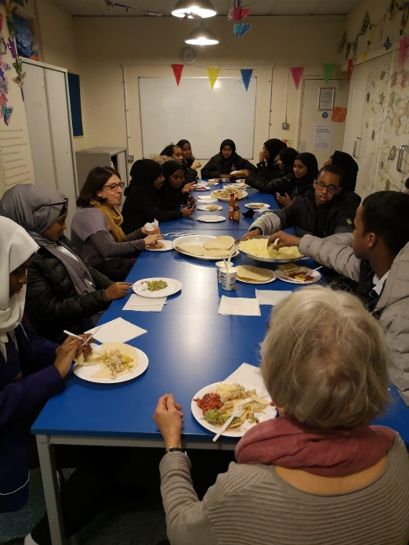 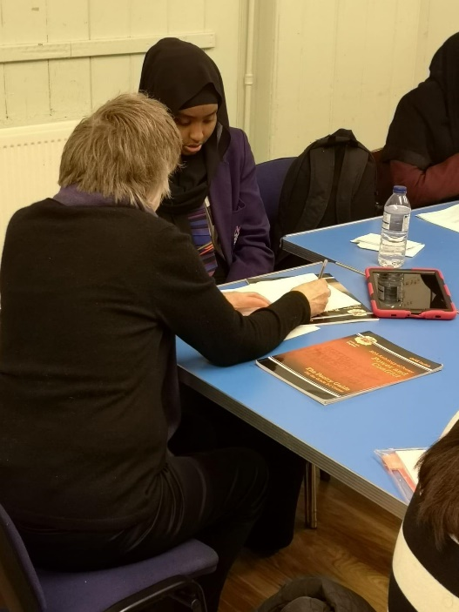

*Spending time together*

1. **Salma’s Story**

Salma is in Year 12 and has been coming to our GCSE Study Group since 2019.

Salma came to the UK from Eritrea with her younger sister when she was 15 years old to join their father. Unfortunately, their mother had to stay in Eritrea. Salma and her sister travelled alone taking a long and dangerous journey. When they arrived, the sisters were out of school for over 10 months. They were supported by our Love to Learn case work team to find a school place and eventually a home. Now in Year 12 Salma is doing well at a local secondary school. She is currently taking GCSE Maths and English.

When she first started coming to the club, in 2019, Salma spoke very little English, struggled to communicate and was finding her schoolwork difficult. Her father does not read or write in English and felt unable to help her. Salma also takes on a lot of responsibility for caring for her sister and general housework. At first Salma was very shy and seemed overwhelmed in the group, however, after building a trusting relationship with staff she opened up about how much she was struggling. Salma works with the same volunteer, Lucy, each week. They have developed a strong and trusting relationship. Lucy is an experienced secondary English teacher, and they were able to continue meeting on a weekly basis, online throughout the first and second lockdowns.

As a result, Salma's confidence has grown immensely. She attends twice a week and has never missed a session. Lucy gives her specific tasks to support with her language as well as helping with her homework. Salma has also made a number of friends in the group who give her a lot of support.

During the first lockdown Salma and her sister were each given a laptop to support them with their online work. They also took part in our summer programme attending at least 3 times a week, for 5 weeks. Salma told us, *"If I didn't have the club, I wouldn't have help I don't know what to do, now I know Jo and Abdul can look at my work and if I don't understand they help me. Now I don't feel I am alone"*. And Lucy, her volunteer, said, *"We had a really good session today; her writing skills have visibly improved and she has much more confidence nowadays which is really good to see."*

1. **Plans for the future**

We plan to continue our GCSE Study Groups for the benefit of local refugee young people in Battersea and those living in the wider Wandsworth community. This support has become even more important as the pandemic has adversely impacted on young people’s education.

1. **Further information**

If you would like further information about our GCSE Study Group, or would like to come and visit in the new year when it’s safe to do so, then please get in touch with Paula Robertson, our Head of Love to Learn, on [paula@love-to-learn.org.uk](mailto:paula@love-to-learn.org.uk).

Thank you again for your support.

