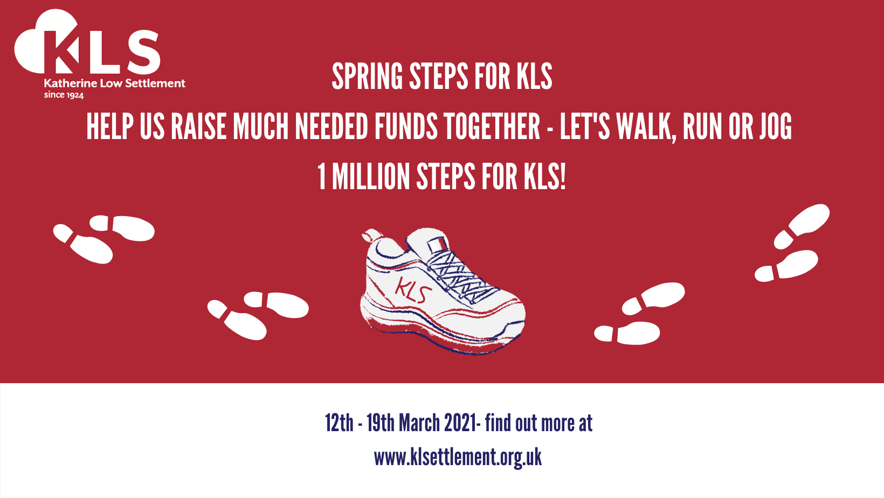
Together let’s walk 1 Million steps for KLS!

Can you help us walk One Million Steps for KLS in just one week?

This is our first virtual fundraiser and a fantastic opportunity bring our community together for a common goal. Sign up HERE

We launch at noon on 12th March – the final tally will be at noon on 19th March 2021

Help us walk 1 Million steps in a week and earn much needed funds for KLS. Log your steps from anywhere in the world and join in the community effort to support KLS.

How does it work?

Walk as many steps as you can manage, even just a few will make a huge difference. You don’t need a fancy pedometer, just estimate your steps based on how long you walk for.

The average person walks around 100 steps in a minute
To walk 5,000 steps, which is about 2.5 miles, will take you about 45 minutes.
To walk 10,000 steps, which is about 5 miles, will take you about an hour and a half.

1 Million steps is equal to 500 miles!

Who can take part?

Everyone can take part from anywhere in the world so get your trainers on and walk for KLS.

How do I collect sponsorship?

It would be amazing if you could ask friends and family to sponsor your efforts but just join in with the walk if you would prefer not to be sponsored this time – we’ll still count you steps towards our total.

To set up a sponsorship page simply visit our Virgin Money Giving Event Page HERE to find out how. You can set up a sponsorship page as an individual or a team, maybe your office or school would like to set their own team step goal, walk in fancy dress or carrying an egg on a spoon!

Tell us how you are doing!

Swap your walking stories, steps taken and top tips for good local walks.

Visit our Padlet map - https://padlet.com/annabel51/w4r8pyqfjqc8wii8
post your steps or a photo on our interactive map. Here’s a QR Code for our Padlet Map

Send something on Facebook, Twitter or Instagram
https://twitter.com/klsettlement
https://www.instagram.com/katherinelowsettlement/
https://www.facebook.com/klsettlement

Email us annabel@klsettlement.org.uk

Useful Links and Information

When you set up your page you may like to include a short description about Katherine Low Settlement and why you are taking part, we have included some suggestions below. We have also attached a link to our KLS Logo and the Event Logo. If you’d like to chat about the event or need any further information please email annabel@klsettlement.org.uk

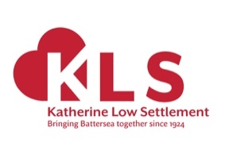
I/we are joining the Spring Steps for KLS virtual sponsored walk to raise much needed funds for this local charity. We will be walking (insert your target here) steps between 12th and 19th March to help KLS towards their target of 1 Million Steps. We’ll keep you posted on our progress!

Katherine Low Settlement has been serving Battersea and the wider Wandsworth community since 1924. They are dedicated to building stronger communities and enable people to challenge and find ways out of poverty and isolation. KLS run a range of their own community projects to support thousands of children, young people and their families, women, older people and refugee communities. Visit their website to find out more www.klsettlement.org.uk

Find out how KLS has been supporting the community throughout lockdown and how it is looking forward to a brighter future in this short film https://www.youtube.com/watch?v=oPV8sX1cQ4o&t=1s

Call us for a chat 020 7223 2845

Thank You!
A massive thank you from everyone at KLS – we need your support to enable us to continue to support vulnerable people in Battersea – we really can’t do this without you.

Visit our Event Page

