# BIG_LOCAL_logo2a.jpg

**Big Local SW11 & Battersea Alliance**

**Area Profile & Community Needs Assessment**

September 2021

Contents

[Executive Summary 1](#_Toc81911956)

[Context 2](#_Toc81911957)

[Summary of Community Needs 4](#_Toc81911958)

[1. COVID -19 9](#_Toc81911959)

[2. Population, Size & Ethnicity 11](#_Toc81911960)

[3. Poverty – Indicators of Deprivation 16](#_Toc81911961)

[4. Health and Mental Health 20](#_Toc81911962)

[5. Housing 24](#_Toc81911963)

[6. Overcrowding, Isolation and Loneliness 26](#_Toc81911964)

[7. Education – Participation and Attainment 30](#_Toc81911965)

[8. Young People 33](#_Toc81911966)

[9. Older People 37](#_Toc81911967)

[10. Black and Minority Ethnic Issues in BLSW11 & Battersea 41](#_Toc81911968)

[11. Economy 43](#_Toc81911969)

[12 Environment 47](#_Toc81911970)

[13 Locality 49](#_Toc81911971)

[14 Digital Exclusion 50](#_Toc81911972)

[15 Community Needs 52](#_Toc81911973)

[16. Gaps in Information and Knowledge 53](#_Toc81911974)

[Appendix 1: Methodological Issues 54](#_Toc81911975)

[Appendix 2: Maps, BLSW11 & Battersea 56](#_Toc81911976)

[Appendix 3: Data Sources 57](#_Toc81911977)

[Appendix 4: Community Needs - Definitions 61](#_Toc81911978)

[Appendix 5: Defining Digital Use 63](#_Toc81911979)

## Executive Summary

The following report provides a summary of the key statistics for BLSW11 and Battersea contrasted with LB Wandsworth and, where relevant, London or England.[[1]](#footnote-1)

In the BLSW11 and Battersea area, people overall:

* Have a strong sense of community with good ‘community assets’
* Support a range of community organisations
* Have good access to main services (GP, pharmacy, schools)
* Children perform well in early years

But, when compared with the London Borough of Wandsworth, people living in the BLSW11 area are more likely to:

* Live in overcrowded conditions
* Live in poverty
* Be a lone parent
* Come from a BAME community
* Experience isolation and loneliness
* Experience poor mental health
* Be unemployed and/or long-term unemployed, or have never worked
* Have a poorer quality environment
* As a young person, you are less likely to go on to higher education
* Die earlier

Since 2015, when BLSW11 produced its first Strategy and Plan, there have been some notable changes:[[2]](#footnote-2)

* The population has risen from 15,358[[3]](#footnote-3) to 17,474
* Some of the population increase appears to be from inward migration from Europe
* More people live in rented accommodation
* Fewer pupils go on to higher education
* Mental health issues have become more apparent and discussed

The COVID-19 pandemic has exacerbated loneliness and isolation and has had a big impact on people’s mental health; with a disproportionately negative impact on BAME communities and those with underlying health conditions, particularly in poorer areas.

## Context

The main aim of this report is to provide a resource for the people and local communities in the BLSW11 and Battersea area.

In 2016, the first Battersea Together event saw 75 people representing 45 organisations come together to look at the community needs of the BLSW11 and Battersea area.

In 2017, the second Battersea Together event looked more closely at the evidence, particularly evidence that was related to areas of concern that were not being adequately addressed by traditional institutions. This led to research into community needs and the realisation that the biggest barriers preventing people from realising their potential were Isolation, Loneliness and Mental Health (Anxiety and Depression)

The third Battersea Together Event, under the title From Words to Action, saw the birth of the BLSW11 Alliance (now, Battersea Alliance) and the emergence of an evidence-based partnership and community development approach to tackling isolation and mental health challenges.

**Community Development Approach**

The evidence is overwhelming: social connectedness is a strong indicator of health and well-being and poor social connections lead to poor health and mental health outcomes, with some studies arguing that it can be more important than obesity and smoking as a predictor of mortality.[[4]](#footnote-4)

The community development approach adopted by BLSW11 and the Alliance is simply this: that many of the challenges faced by individuals can be answered by strengthening social connections!

A more detailed account might refer to ‘social capital’ as the glue that binds people together: Some areas are ‘rich’ in social capital with multiple forms of interaction between people through neighbourhood associations, clubs, community groups, trusts, charities and strong kinships; others are ‘poorer’, with few opportunities for people to come together with shared common purposes.

Communities with strong social capital are better placed to deal with threats and take advantage of opportunities than those where social capital is weak. Social capital is essentially about how people interact and relate to each other.[[5]](#footnote-5)

**Who should read this?**

The underlying aim here is that, as far as possible, our collective aims and local interventions/actions should be guided by evidence.

With this in mind, the following are encouraged to use the data and analysis provided, not as a definitive account, but as a useful tool:

**Local residents and Community Groups** – for people who live, work or volunteer in the BLSW11 or Battersea area; to help in the development of projects and programmes, the preparation of funding bids and to gain a voice and confidence in arguing for better services and new investment.

**Policy Makers** – whether the LB Wandsworth, Clinical Commissioning Group, the Greater London Authority or Corporate interests whose actions impact on BLSW11 and Battersea, so that they can gain an insight into the Community Development approach advanced here and, where possible, tailor their policies and interventions to advocate and support measures that empower local communities.

**Funders** – critically, funders are encouraged to think beyond their areas of specialism or individual concerns to develop longer-term and more strategic measures, where possible collaborating with the local community in the design and delivery of funding programmes.

**Other Stakeholders** – there are many organisations in the Community Voluntary Sector (Churches, National NGO’s or Charities) and Private sector based near or in Battersea that work to support groups, vulnerable people or special interest groups who could make a powerful contribution towards strengthening the communities of BLSW11 and Battersea.

**A note on methodology**

A detailed account of methodological issues is given in Appendix 1. Here, we note that this report is almost entirely based a quantitative data and a fully comprehensive community needs assessment would be enhanced or may be supplemented with a degree of qualitative analysis drawing, perhaps, on personal accounts or case studies to go beyond the dry data.

Looking ahead, it is proposed that BLSW11 and the Alliance develop thematic studies to further strengthen the evidence base and to inform policy.

## Summary of Community Needs

The following table sets out a range of inferences drawn from the evidence to inform a community development approach.

|  |  |
| --- | --- |
| **Issue/Theme for BLSW11**  Follow hyperlink to the relevant section | **Needs & Challenges[[6]](#footnote-6)** |
| [**Population**](#_Population,_Size_&)  The population is growing and becoming more diverse. | Greater diversity requires more nuanced responses to community needs.  A growing population will increase pressure on public services.  Population growth from inward migration involves community cohesion. |
| [**Poverty**](#_Poverty__–)  Poverty is strongly correlated with all indicators of deprivation and unmet individual and community needs. | Community action to reduce poverty and the building of social capital gives people greater resilience in coping with poverty.  Poverty was a ‘cross-cutting’ theme of the previous BLSW11 Strategy. |
| [**Health**](#_Health_and_Mental)  Health inequality = why do people in BLSW11 die earlier? Is this linked with poverty? | Promoting active communities can also bring people together.  Mental Health = to increase access to and take up of existing services; to develop mutual support and community-based responses  Mental Health = the number of people who experience mental health challenges but who are not diagnosed or who are not supported.  Mental Health = the absence of preventative measures (like improving connections) |
| [**Housing**](#_Housing)  The growth in private rented accommodation presents challenges in terms of continuity, turn-over and instability. | Private ownership, private rented and social housing co-exist within the same neighbourhoods of BLSW11 and Battersea – does this present specific challenges and opportunities in terms of building social cohesion?  Are enough homes being built that meet the needs of people in 2021? |
| [**Overcrowding**](#_Overcrowding,_Isolation_and)  People in overcrowded accommodation may experience multiple challenges. | Inadequate housing supply  Cluttering, hoarding and poor management of living space  Links with mental health challenges |
| [**Loneliness**](#_Overcrowding,_Isolation_and)  While living alone is not a definitive indicator of feeling lonely, it is strongly correlated.  People living alone in BLSW11 may not have trust in conventional types of support. | Loneliness is associated with multiple health and other challenges.  There are significantly more single parents in BLSW11. |
| [**Education**](#_Education_–_Participation)  Educational attainment is strongly correlated with social mobility and life chances. | The unexplained difference between early years and Key Stage 4 performance  The relatively low level of young people in BLSW11 entering higher education  More pupils in BLSW11 are eligible for free school meals. |
| [**Young People**](#_Young_People)  More young people in BLSW11 are likely to be NEETS, in a Pupil Referral Unit or are excluded from school. | Growing numbers of young people face mental health challenges.  Fewer young people enter employment.  The relatively high number of lone parents may have consequences for education, progression to higher education, peer support and role models. |
| [**Older People**](#_Older_People)  Many older people in BLSW11 have lost family, kinship and friendship networks and support. | Many older people in BLSW11 and Battersea live alone and in relative poverty.  Living alone can lead to feelings of isolation and loneliness which has a negative impact on health in general and mental health in particular. |
| [**BAME**](#_Black_and_Minority)  BLSW11 and Battersea are becoming more ethnically diverse. | To better understand the lived experiences of people that experience abuse or are disadvantaged because of the colour of their skin, their culture or race  To create greater diversity in all forms of engagement and representation; to confidently address structural racism |
| [**Economy**](#_Economy)  Unemployment, never worked and long-term unemployment are higher in BLSW11 | Part-time, elementary jobs are more prevalent in BLSW11.  More jobs were vulnerable to the effects of COVID -19 in BLSW11 and for young people.  Unemployment contributes to mental health challenges. |
| [**Environment**](#_Environment)  A Poor environment has a negative impact on health, mental health and well-being. | Air quality is poor in parts of the BLSW11 area.  People in parts of BLSW11 have less access to ‘green spaces’. |
| [**Locality**](#_Locality)  There is a lack of community representation or organisation in many areas within BLSW11. | Local areas have different needs that may need specific responses. |
| [**Digital Exclusion**](#_Digital_Exclusion)  Too many people have no or poor access to information technology, and many that do have access lack skills and knowledge about its use. | Many older people in BLSW11 are digitally excluded, may not have Wifi or Broadband and/or lack the resources to fully participate.  Overcrowding may exacerbate digital exclusion (lack of space/privacy). |
| [**Community Needs[[7]](#footnote-7)**](#_Community_Needs)  While Community Assets are strong, community connectivity is poor. | While BLSW11 is relatively strong in having community assets like the community and youth centres, churches and schools, it does less well in terms of social connectivity, which may be a result of poor community engagement and participation. |
| [**Gaps in data and knowledge**](#_16._Gaps_in)  There are areas of assumed community need where evidence is of poor quality or lacking | Further research may be need to better understand the needs of:   * Carers * Transitional groups * Refugees * LGBTQ+ communities * EU citizens * Areas of BLSW11 & Battersea that are under-represented |

## COVID -19

## 

* 1. Within 12 weeks of the outbreak of the COVID pandemic, the NCVO estimated that the community voluntary sector had lost £4.2 billion in income.[[8]](#footnote-8) At the same time, the demand for services and support provided by the Sector, often to the most vulnerable in our communities, grew exponentially.
  2. Food poverty, digital exclusion, rises in isolation and loneliness and mental health challenges became widespread.
  3. As early as April 2020, the Institute of Fiscal Studies showed the uneven negative impact of COVID, particularly on ethnic minorities, and particularly the Black Caribbean population.[[9]](#footnote-9)
  4. By June 2020, it had become clear that poverty was a key factor in the unevenness of COVID-related deaths, and that the pandemic also increased poverty rates and distribution[[10]](#footnote-10)
  5. But COVID-19 also witnessed a surge in volunteering and community action[[11]](#footnote-11). By June 2020, over 2000 new mutual aid groups had been established; by April 2021, this had risen to 3000.[[12]](#footnote-12)
  6. Unsurprisingly, the lockdowns had a dampening effect on volunteering but also saw more people moving towards the provision of online support, which, in turn, raised new challenges for those without access to or familiarity with IT.
  7. The pandemic also had an uneven effect on employment, with more people in the hospitality and elementary sectors losing their jobs, and more so in areas that were relatively poor.

**Local Impact**

* 1. The pandemic’s local impact can be illustrated through the range of responses to it, including:
  + Waste-Not-Want-Not –Battersea, run by volunteers and operating from various locations in Battersea, WnWn provided food and support for 1000s of people in Battersea
  + LB Wandsworth – the Council’s £100k COVID-19 response fund supported 27 community organisations
  + The Coronavirus Angels – led by St Mary’s Battersea and supported by a wide range of partners, “helping over 600 people in many and various ways”
  + Kambala Care – provided hot food for hundreds of families in and around the Kambala area
  + JCT – built on its local engagement work to develop direct support for many vulnerable families
  + Falcon Estate Residents Association – developed regular support for over 40 local people/families
  + The BLSW11 Alliance COVID-19 Community Support Fund – supported 30 projects and over 3000 people with grants valued at £100k
  + Women of Wandsworth delivered a range of support for vulnerable people
  + Battersea Befrienders – recruited more volunteers to establish ongoing befriending for some of the most isolated people in Battersea
  + Age UK (Wandsworth) developed online support services
  + Share Community tailored their support to meet individual needs
  + Battersea Elders developed online and telephony support services
  + Sound Minds created ‘covid-free’ safe spaces
  + Mutual Aid – established an extensive communications network to promote self-help and offer advice and guidance
  1. In addition, there are many anecdotal accounts of local people helping each other and the most vulnerable in their communities.

## 

## Population, Size & Ethnicity

**Key Findings/Issues**

* The population in BLSW11 has grown and will continue to grow; some of the growth is because of inward migration, mainly from Europe and Africa.
* Any further population growth will impact social services and have implications for housing, education, jobs and engagement in the wider community.
* A community development approach would seek to engage with all parts of the community to encourage participation and working partnerships.
  1. The population of the BLSW11 area has risen since its foundation, from 15,200 to 17,768, and it is predicted to grow to above 20,000 by 2035[[13]](#footnote-13).

**Population and Population Forecast (Source: GLA 2016 Projections)**

* 1. The probable reason for this growth is not from a higher birth/lower death rate but because of net inward migration which is reflected in the Inflow figures:

**Inflow Outflow[[14]](#footnote-14)**

* 1. The evidence, while not definitive, suggests that a significant element of inward migration has been from Europe (Other White) and Africa, contributing to greater ethnic diversity in BLSW11. The impact of Brexit (particularly for European migrants) is not reflected in the current figures.
  2. Compared with Battersea and the rest of Wandsworth, the BLSW11 area has a significantly larger proportion of people classified as non-white.

**White British & Non-White**

* 1. Black Caribbean and Asian ethnic groups also contribute to the growing diversity in BLSW11.

**Ethnicity – Non-British White**

* 1. While white groups still account for almost 60% of the total population of BLSW11, Black groups are better represented in BLSW11 than for Battersea and Wandsworth. This should, perhaps, be a factor in how our local communities are represented and how community support is designed.

**White & Black %**

* 1. The correlation between ethnicity, ethnic diversity and poverty, while strong, does not give an unambiguous causal account as there are significant differences within and between different ethnic groups.[[15]](#footnote-15)

**Ethnicity & Deprivation**

* 1. However, as we see in Section 9, there is compelling evidence that the correlation is more than a statistical coincidence.
  2. Cultural diversity is a potential strength for the communities of BLSW11 and Battersea which should be reflected in local forms of representation and community participation.
  3. Unsurprisingly, ethnic diversity is also reflected in religious diversity, where BLSW11 shows a higher proportion of people of a Muslim faith than for Battersea, Wandsworth and England

**Religion**

* 1. We know from other studies that religion can be an important factor in the development of social cohesion[[16]](#footnote-16) and it may be inferred that religious organisations and groups within a community could be major contributors towards strengthening community resilience.

## Poverty[[17]](#footnote-17) – Indicators of Deprivation

**Key Findings & Issues**

* Across all indicators, poverty is more prevalent in the BLSW11 area than in the rest of Wandsworth.
* Children in out-of-work families and pensioners are more likely to live in poverty.
  1. Across a range of indicators, BLSW11 scores poorly on measures of deprivation, perhaps most strikingly for children in out-of-work families and pensioners in poverty. (EDI = Economic Deprivation Index)
  2. It is estimated that 5,640 people in the BLSW11 area live in the most deprived 20% of areas of England (2019), or 31.7% compared with 16% for London.
  3. The number of households in BLSW11 classed as living in poverty is higher than for Battersea and Wandsworth.

**Households in Poverty**

* 1. Perhaps most striking (and disturbing) are the levels of poverty experienced by children in BLSW11 across all age groups.

**Children in Poverty by Age**

* 1. At the other end of the age spectrum, older people in BLSW11 are significantly more likely to live in poverty.

**Older People in Poverty**

* 1. Together, children and pensioners in poverty represent a major challenge for all those involved with or interested in the well-being of our communities.

**Children & Pensioners in Poverty (% Total)**

* 1. In BLSW11, the number of pensioners who are single and who get pension credits is more than twice the percentage for Wandsworth!
  2. The combination of poverty and single status for many older people is likely to present further serious challenges for health, well-being and people’s involvement with and sense of community belonging.

**Summary**

* 1. There is strong evidence that poverty correlates with all indicators of deprivation and unmet individual and community needs.[[18]](#footnote-18)

## Health and Mental Health

**Key Findings & Issues**

* According to most indicators, BLSW11 has significantly higher health inequalities than Wandsworth.
* Life expectancy is lower.
* Unmet mental health needs are higher.
* Access to mental health services is lower.
  1. Strikingly, life expectancy in the BLSW11 area is lower than that for Battersea, Wandsworth and London.
  2. The reasons for this are not singular and further detailed investigation may be required, but the morbidity and mortality rates do show consistency across a range of indicators.[[19]](#footnote-19)

* 1. As well as a lower life expectancy, people in BLSW11 are also more likely to have fewer disability-free and healthy life-free years.

* 1. This implies there are not only implications for the health and other social services but for the communities themselves.

**Mental Health**

* 1. The main indicators for mental health derive from GP practices and survey work, which can show contrasting and, sometimes, apparently contradictory results.
  2. For example, the rates of mood anxiety and depression recorded by GP’s shows a degree of uniformity across all areas.
  3. Yet the figures derived from survey work show a very different picture.
  4. The Small Area Mental Health Index[[20]](#footnote-20) suggests a much wider prevalence of mental health issues in the BLSW11 area. One possible explanation for this is that a significant number of people experiencing mental health challenges in the BLSW11 area do not report this to their GPs!
  5. If this assumption is true, there will be significant implications for community organisations and residents, with major challenges being to increase access to available services while also developing a community response to promote mutual support and engagement.

**Summary**

* 1. While the prevalence of disaggregated health inequalities appears to be reasonably well-described, the apparent gap between those that fall within mainstream mental health support and provision and those that lack support must be a cause of concern for individual and community well-being.

## Housing

**Key Findings and Issues**

* Far more people in BLSW11 live in social housing than the rest of the Borough.
* The private rented sector has been growing and fewer people in BLSW11 own their own homes.
  1. While there are numerous issues and consequences that are connected with housing, this ‘needs’ assessment is primarily concerned with those that impact community development, such as tenure type (which affects mobility), ownership (which can impact on a person’s sense of security) and quality of accommodation (which may have significance for well-being).
  2. In the BLSW11 area, the social rented sector is more than double that of Wandsworth and owner-occupied housing significantly less.

**Housing by Tenure**

* 1. It is not uncommon for Estates in the BLSW11 to have a mix of tenure types with private ownership, social housing and private rented accommodation in the same location.
  2. This can present challenges for community cohesion as some people see their common interests more aligned to their personal status rather than to the wider community.

**Overcrowding**

* 1. Overcrowded housing is also higher in BLSW11 than in Battersea and Wandsworth.[[21]](#footnote-21)

**Overcrowded Housing**

* 1. The problem of overcrowding is also associated with the average number of rooms per household, with the evidence showing that BLSW11 compares unfavourably with Wandsworth.

**Number of Rooms**

* 1. There are more one and two-room properties in BLSW11 and far fewer houses with nine or more rooms.

**Summary**

* 1. The characteristics, types and quality of housing have a direct bearing on a key issue for BLSW11 and Battersea: overcrowding, isolation and loneliness.

## Overcrowding, Isolation and Loneliness

**Key Findings & Issues**

* More people live in less space in BLSW11.
* Isolation is more acute, particularly for lone parents and older people.
* There is greater loneliness, particularly, but not only, for older people.
  1. Population density indicates the relative compactness of where people live and, in this regard, many people living in the BLSW11 area live a lot closer together than those in Wandsworth and London in general.

**Population Density**

* 1. 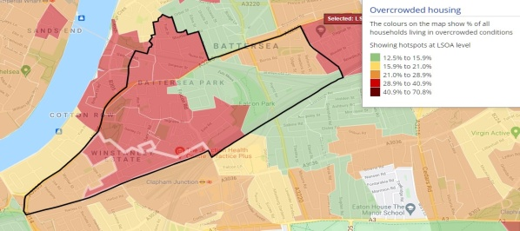Overcrowding[[22]](#footnote-22) in the BLSW11 area is centred on the Winstanley and York Road estate. It is undergoing a major regeneration programme which - as with any regeneration programme - should have a positive impact on those who live in the area; however, it is unclear if the current tenants will be beneficiaries of the programme at all.
  2. Although the figures do not show a dramatic difference, it is noteworthy that on all the main indicators of overcrowding and living alone, the BLSW11 area appears to be worse than the rest of Wandsworth (and London).

**Living Alone**

* 1. But, beneath the broad categories of people, some striking differences do exist, particularly for lone parents:

**Lone Parent Households**

* 1. While living alone does not necessarily equate with either the experience of feeling isolated or lonely, there is a strong correlation.
  2. As the causes and effects of loneliness are becoming better understood, it is not known how far the national implications and trends identified by the Campaign to End Loneliness apply to BLSW11 and Battersea.

**Campaign to End Loneliness – Key Facts[[23]](#footnote-23)**

**Health risks**

* Loneliness is likely to increase your risk of death by 26%.
* Loneliness with severe depression is associated with early mortality and loneliness is a risk factor for depression in later life.
* Loneliness and social isolation put individuals at greater risk of cognitive decline and dementia.

**Loneliness and older people**

* The number of over-50s experiencing loneliness is set to reach two million by 2025/6. This compares to around 1.4 million in 2016/7 – a 49% increase in 10 years.
* Half a million older people go at least five or six days a week without seeing or speaking to anyone at all.

**Loneliness and people of all ages**

* In total, 45% of adults in England feel “occasionally”, “sometimes” or “often” lonely. This equates to 25 million people.
* From 2016 to 2017, 5% of adults (aged 16 years and over) in England reported feeling lonely “often/always” – that is 1 in 20 adults. Furthermore, 16% of adults reported feeling lonely sometimes and 24% occasionally.
* Research commissioned by the Eden Project initiative The Big Lunch found that disconnected communities could be costing the UK economy £32 billion every year.

**Gender and Loneliness**

* According to the ONS, women reported feeling lonely more frequently than men. They were significantly more likely than men to report feeling lonely “often/always”, “some of the time” and “occasionally” and were much less likely than men to say they “never” felt lonely.
* While higher percentages of older women report loneliness compared to men, a greater number of older men (50+) report moderate to high levels of social isolation.
* 14% of older men experienced moderate to high social isolation compared to 11% of women

**Loneliness and families**

* A survey by Action for Children found that 43% of 17 – 25-year-olds who used their service had experienced problems with loneliness, and that of this same group, less than half said they felt loved.
* Action for Children has also reported 24% of parents surveyed said they were always or often lonely.

**Loneliness and disabled people**

* Research by Sense has shown that up to 50% of persons with disabilities will be lonely on any given day.

**Summary**

* 1. Loneliness or the feeling of being alone can be corrosive, leading those experiencing it to feel detached and disconnected from their communities (of place, of interest, of culture, etc.).
  2. Loneliness can be addressed (in part) by building or strengthening social capital.[[24]](#footnote-24)

## Education – Participation and Attainment

**Key Findings and Issues**

* There appears to be a falling-off of attainment from early years to Key Stage 4 ( GCSEs).
* Fewer pupils in BLSW11 go on to higher education.
* ‘Problem’ areas (NEETS, PRU) appear to be higher and more prevalent for Black children.
* The average percentage of children eligible for free school meals is 24% for Wandsworth, reaching 62% for Christchurch and Falconbrook schools.
  1. Children’s absentee rates in BLSW11 and across all measures are on a par with average rates in Battersea, Wandsworth and the rest of London.

**Absentee Rates**

* 1. While early years’ development appears evenly distributed, there does appear to be a slight decline in BLSW11 achievement by the time pupils take their GCSEs.

**From Early Years to GCSE**

* 1. The available evidence does not account for this difference but there then appears to be a dramatic decline in the number of young people that go on to higher education.

**From Foundation to Higher Education**

* 1. What accounts for this?
  2. When we add into the account that a significantly higher number of people in BSW11 have no qualifications, it would be reasonable to assume that for some young people in the area formal education ceases at 16+. This may also account for the assumed relatively high NEETs levels in BLSW11.

**No Qualifications**

**School Level Data[[25]](#footnote-25)**

* 1. The following highlights provide further evidence of the challenges faced by young people and families in the BLSW11 (here, based on Latchmere Ward):
* The percentage of homes with good access to nature amounts to 91% for Wandsworth, 57% for Latchmere.
* Pupils eligible for free school meals amount to 24% for Wandsworth and 62% for Falconbrook and Christchurch (both in Latchmere).
* Pupils with a first language other than English measure 40% in Wandsworth 69% for Falconbrook.

**Summary**

* 1. For some children in the BLSW11 area, the journey from infancy to adulthood appears to be marked by periodically poorer development, perhaps linked to the transition points from nursery to infant school, to primary school, to college and/or higher education and finally to employment, with young people in BLSW11 progressively doing less well than their Wandsworth counterparts.

## Young People

**Key Findings & Issues**

* Young people in BLSW11 are more likely to be unemployed than in Wandsworth as a whole.
* It is probable that BLSW11 young people make up a higher proportion of those in NEETs or PRU.
* Black youths are more likely to encounter the criminal justice system or to experience stop and search.
* Youth mental health issues are increasing.
  1. According to the State of the Nation 2020: Children and Young People’s Well-being report (Department for Education)[[26]](#footnote-26),
* The majority of children and young people report being relatively happy with their lives, but many are not.
* Well-being declines as children and young people get older.

* There were few consistent differences in well-being by gender in children, but young females were more likely to report recently feeling anxious than males.

* 17% of children overall reported being bullied in 2017-18.
* Well-being and mental health in teenage girls is a pressing issue given reports of the increasing incidence of emotional problems as they move through adolescence.
* Psychological health was poorer for girls than boys of the same age but declined during adolescence for *both* boys and girls.
* Experiences of being bullied, including online bullying, was the risk factor most strongly associated with psychological health throughout mid to late adolescence.
  1. These national findings provide a context for local issues but with more than 40% of London’s Youth Clubs under threat of closure[[27]](#footnote-27) and an estimated 480,000 young people annually who are ‘hidden’ in the UK (i.e., not in work and not claiming benefits)[[28]](#footnote-28), there is mounting evidence that the national data cannot be readily applied to local circumstances.
  2. In particular, there is evidence that young people are amongst the worst affected by the COVID-19 Pandemic. A 2021 [Institute for Employment Studies labour market analysis](https://www.employment-studies.co.uk/system/files/resources/files/IES%20briefing%20-%20Labour%20Market%20Statistics%20October%202020.pdf) showed that three-fifths of the fall in employment is due to fewer young people being in work, while benefit claims among the under-25s have risen by [125%](https://commonslibrary.parliament.uk/research-briefings/sn05871/), with one-in-seven young people now claiming benefits. Young people are  [2.5 times more likely](https://www.ifs.org.uk/uploads/BN278-Sector-Shutdowns.pdf) to be working in the sectors most affected by the pandemic.[[29]](#footnote-29)

**NEETS**

* 1. 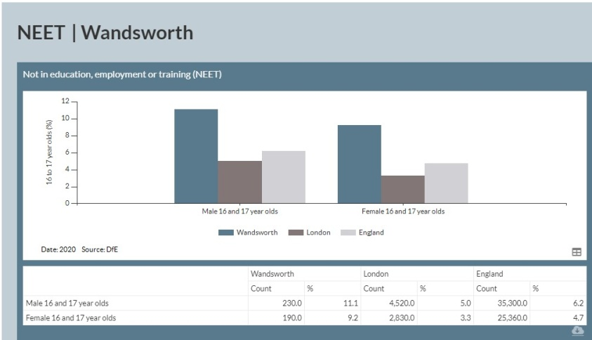The number of young people not in employment, education or training (NEETS) in Wandsworth is significantly higher than it is in London and England. And, while the data is not available at ward level, it is probable that there is an association with the more deprived areas of Wandsworth, including the BLSW11 area.
  2. Again, while the national data suggests that young people are disproportionally disadvantaged in the labour market, this is more pronounced for young people in the BLSW11 Area.

**Youth Unemployment**

* 1. The following extracts from Carney’s Community’s Lived Experience report (2021), based on interviews with young people, bring to the fore some of the issues and challenges faced by young people in Battersea.[[30]](#footnote-30)
* When young people were asked what their experiences were, regarding the police and crime, in their local area, the first thing they highlighted was that they did not feel safe and this sense of fear related both to others who were involved in crime and youth violence as well as their experiences with the police. Many of them felt growing up in estates and being black meant you could not avoid gangs and youth violence.
* Anxiety was increased at times, due to them being stopped and searched, for what they felt was no apparent reason.
* Starting secondary school is scary and many pupils put on a front, mainly due to fear.
* There were concerns raised about schools being too prescriptive and not listening enough to what pupils have to say. Examples were given of pupils having a lot of other issues going on around them that they have to deal with, such as health issues (physical and mental), parental and other family issues (including health), bullying, abuse, poverty, being a young carer, etc. They felt schools often did not take this into account and that the schools should consider pupils’ situations holistically to help them understand them better.
* In relation to housing, there were examples of general overcrowding, such as seven living in a three-bedroom flat, with a 16-year-old girl and 14-year-old boy sharing a room.
  1. Regarding education and life chances, young people (particularly from BAME communities) in BLSW11 compared with Wandsworth were more likely to:
* Be excluded from school.
* Be sent to a pupil referral unit.
* Experience ‘stop and search’.
* Experience the criminal justice system.
* Live in poorer families.
* Live in overcrowded conditions.
  1. On the evidence, it appears that while the needs of young people are becoming more pronounced in the areas of employment, poverty, loneliness, and mental health, the infrastructure, organisational and community development needed to support them is being reduced.

**Summary**

* 1. From a community development perspective, the evidence suggests that more young people living in BLSW11 are becoming detached from the mainstream in terms of higher education, jobs and training, which might contribute to an increased involvement in the informal economy and non-traditional forms of social mobility.
  2. The needs of young people are likely to be multi-various and complex and the needs of young people in the BLSW11 and Battersea area, who experience economic and social disadvantages, are likely to be more challenging.

## Older People

**Key Findings & Issues**

Older people in BLSW11 are more likely to:

* Live in poverty.
* Live alone.
* Feel isolated or disconnected from their community.

* 1. According to Age UK, more than two million people in England over the age of 75 live alone and more than one million say that they go for over a month without speaking to a friend, neighbour or family member.[[31]](#footnote-31)
  2. The following is taken from KLS’s Age Well Participatory Needs Assessment (April 2021).
* There are concerns about the people who are not connected to community services and how to reach them. These concerns existed before the pandemic, and research shows that during the pandemic more people will have become isolated and in need.
* People primarily find out about activities through word-of-mouth. Without recommendations from trusted acquaintances, there is a need for more persuasion and one-to-one conversations. Opportunities for word-of-mouth recommendations have been drastically reduced during the pandemic.
* While the community sector is skilled at the necessary conversations, it lacks the level of specialist knowledge that exists in corporate marketing and PR firms on how to reach people, and the budget to purchase this knowledge/these services.

* There are three groups of older people in need. A group of younger old (under 60) who, due to previous social/economic disadvantage, have reduced physical health and/or mental health but for whom there are no affordable services.

* There is a pre-fail group of people in their sixties and seventies who remain unconnected to the community as they do not consider themselves old and, therefore, do not connect until there is a crisis, (bereavement, health, etc.). Sometimes, this means that they are then unable to access support when they most need it.

* There is the silent generation of older old who are often the hardest to reach, and are the least heard. Stakeholders spoke less about the unmet needs of this group. This could be because these were the age groups that were already being supported; however, it is likely that there is a cohort of this silent generation who are currently invisible and unreached.
* Within all three groups, men are the least likely to engage with services and activities. There is the need for targeted work with older men, many of whom struggle with social connection and who view needing support as an indication of weakness, as indicated by some of the responses within the PNAs

.

* There remains a lack of data about the needs of the older LGBTQ population. To gain this knowledge may require a more specialised piece of research as part of the Age Well project in Year Two.
* London’s older population has complex needs arising from histories of dislocation and discrimination for the elderly from London’s diaspora communities, and for a growing number of young old, those with histories of poor physical and mental health and complex needs
* The impact of the pandemic on the older population has led to an increased need among the older population and the need for more skilful interventions around mental health and digital inclusion. Much expertise exists already within the community sector, but the resources of space and time for facilitating the sharing and disseminating this knowledge, perhaps through action learning and cascading, would be beneficial.
* The infamous English rainy summers can make open areas and parks of limited use. Are there possibilities for creating temporarily covered areas over this summer so that outside exercise classes can continue whatever the weather?
* Digital inclusion and exclusion have become major issues and all stakeholders felt that this should be a focus of attention. The fear, frustration and/or lack of interest expressed by older people regarding developing their digital knowledge must be tackled head-on.

* There is a need not only to persuade people to connect digitally but to ensure that their connectivity is affordable in the same way that we combat fuel poverty by ensuring people are on the best financial packages that suit them. The pandemic has brought forward the time when digital inclusion is a necessity.
  1. The KLS report highlights the need for a variety of responses to the unmet needs of older people in Battersea.
  2. At the same time, the positive contribution of older people to society, the economy and communities is often overlooked.
  3. A 2013 GLA report - [‘The Economic Contribution of Older Londoners’](https://www.london.gov.uk/sites/default/files/gla_migrate_files_destination/The%20Economic%20Contribution%20of%20Older%20Londoners%20Final%20Version.pdf) - found that the paid work of those aged 50+ in London contributed £47 billion annually to London’s economy, which is a huge contribution to the capital. It also stated that Londoners aged 65+ contributed £6.3 billion annually to London’s economy through paid work, volunteering, acting as carers and looking after grandchildren.

**Summary**

* 1. Nationally, regionally and locally, there is a range of services and support groups that focus on the needs of older people (Age UK, Silver Surfers, University of the Third Age, Battersea Befrienders).
  2. The challenges facing older people in BLSW11 and Battersea appear to be rooted in poverty and isolation, with many people having lost the support of or connectivity with their families or kinship networks.
  3. At the same time, societal changes, like the growth in the use of digital technologies (see Section 14), further excludes older people from communication systems and online support.
  4. How far older people feel involved with or connected to their wider community may be a strong indicator of their overall well-being.

## Black and Minority Ethnic Issues in BLSW11 & Battersea[[32]](#footnote-32)

Key Findings & Issues

* There is compelling evidence of unequal treatment of BAME communities.
* Institutional racism may be a critical factor in explaining BAME disadvantages.
  1. Apart from the demographic statistics, there is no current information that focuses specifically on the lived experiences of Black and Minority Ethnic communities in BLSW11.
  2. From national and regional (London) sources, we can infer that as a general rule, proportionately:[[33]](#footnote-33)
* Black people are nine times more likely to face stop and search than White People (<https://www.theguardian.com/uk-news/2020/oct/27/black-people-nine-times-more-likely-to-face-stop-and-search-than-white-people>).
* There are more BAME men in prison (<https://commonslibrary.parliament.uk/ethnicity-and-the-criminal-justice-system-what-does-recent-data-say/> : BAME are 16% of the population but 27% of people in prison).
* While Asian pupils do well in education, fewer Black Caribbean pupils attain GCSEs or go on to higher education (<https://ffteducationdatalab.org.uk/2020/10/the-gcse-attainment-of-black-caribbean-pupils-is-falling/>).
* Black Africans are much less likely to own their own homes (<https://www.ethnicity-facts-figures.service.gov.uk/housing/owning-and-renting/home-ownership/latest>).
* BAME (excluding Indian) people are more likely to be unemployed (<https://www.ethnicity-facts-figures.service.gov.uk/work-pay-and-benefits/employment/employment/latest>).
* School exclusion rates may be higher for BAME (particularly Black) pupils (<https://www.ethnicity-facts-figures.service.gov.uk/education-skills-and-training/absence-and-exclusions/permanent-exclusions/latest>).
* In the year to March 2020, Black people were more than four times as likely as White people to be detained under the Mental Health Act – with 321.7 detentions per 100,000 people, compared with 73.4 per 100,000 people (<https://www.ethnicity-facts-figures.service.gov.uk/health/mental-health/detentions-under-the-mental-health-act/latest>).
  1. Some explanations for these disparities link the ‘facts’ to other facts, like the strong correlation with poverty; others suggest that institutional racism is the critical issue (<https://www.gov.uk/government/publications/lammy-review-final-report>).
  2. As noted in Section 2 (Population), BAME communities are an integral part of what characterises the BLSW11 area and, while a dearth of local BME data prevents more detailed analysis, there are compelling reasons why more needs to be done to gain a better understanding of the lived experience of BME individuals and communities.

**Summary**

* 1. With a relatively high BAME population and diverse BAME communities across the BLSW11 and Battersea areas, a community development approach would aim to ensure that people who are or who feel disadvantaged because of their ethnicity are supported to gain a voice and a place in the arena of ideas and policy that might contribute to building a stronger sense of self and community.

## Economy

**Key Findings & Issues**

BLSW11 is characterised by

* Lower economic activity rates.
* More jobs in ‘elementary’ occupations.
* Higher unemployment and long-term unemployment.
* More part-time work.
* More people having never worked.
  1. Economic activity rates show the proportion of a population that are active or potentially active in the labour market (in jobs or looking for employment).
  2. In contrast, the economic inactivity rate shows the proportion of people that are not working or are unable to work (Carers, etc.). For BLSW11, compared with Wandsworth, the activity rate is lower and the inactivity rate is higher.

**Economic Activity**

* 1. The type of work people do can have an impact on their sense of security and well-being.

**Jobs by Sector**

* 1. The distribution of job types shows that BLSW11 is well represented in the Arts, Hospitality. Scientific & Technical and Health sectors, but less well represented in Business Administration, Financial, Retail, Wholesale and Public Administration sectors.
  2. Compared with Battersea, there are marginally fewer full-time, more part-time and more ‘elementary’ jobs in the BLSW11 area.

**Jobs – Full-time, Part-time, Elementary**

11.6 Across all the main indicators associated with unemployment, BLSW11 compares negatively, not just with Wandsworth but also London and England.

**Unemployment, Youth Unemployment, Never Worked**

* 1. Long-term unemployed refers to those who have been unemployed for a year or more; again, BLSW11 compares less favourably with all other comparative groups.

**Long-Term Unemployment**

* 1. While accounting for the lower economic activity rates, higher unemployment, the never worked and long-term unemployed in the BLSW11 area is not straightforward,[[34]](#footnote-34) the persistence of disparities over time suggests some underlying structural explanations may be required.

**Summary**

* 1. There is little doubt that unemployment rates are strongly correlated with poverty rates and with higher mental health challenges. Those in unemployment tend to have lower levels of well-being than those in employment. Those with greater job security tend to have higher levels of well-being. Job quality is also important for well-being; jobs that cause high levels of stress can have adverse effects on well-being. Higher income is associated with higher levels of well-being. There is evidence that the unemployment of a parent may cause a child to have reduced levels of well-being in the longer term. People claiming Job Seekers’ Allowance (JSA) have poorer mental health than the general population (<https://assets.publishing.service.gov.uk/government/uploads/system/uploads/attachment_data/file/278138/Working_well.pdf> ).

## Environment

**Key Findings & Issues**

* People in BLSW11 have poorer air quality than the rest of Wandsworth.
* There is less access to green open spaces.
* A poor quality environment can be an indicator of poor health.
  1. Regarding the environment, while the contrasts with Wandsworth and London as a whole are less dramatic, they are marginally worse for BLSW11 on key indicators:

**Air Quality**

* 1. More strikingly, BLSW11 fares badly concerning access to green space, and the loss of associated benefits that are correlated with it.[[35]](#footnote-35)
  2. While the impacts of the indicators reviewed so far have important consequences, the data available by neighbourhood is scarce and unreliable; however, there are likely to be factors that do have a local character that may influence future interventions in BLSW11.
  3. For example, the regeneration of the Winstanley and York Road Estates will change a physical landscape that has been familiar for generations of local people.

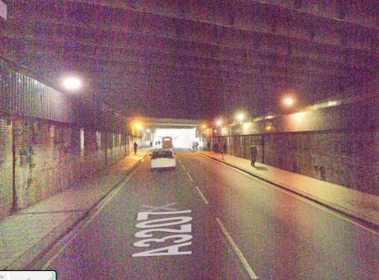

* 1. The tunnel between Falcon Road and St John’s Hill is notorious for its pollution and risks for local people.
  2. The number of tower blocks in BLSW11 present specific environmental challenges, as do the number of neighbourhood areas that lack access to green spaces.

**Summary**

* 1. While attention to the environment will require national, regional and local approaches, the communities of BLSW11 and Battersea can potentially influence the way that policy is considered and developed.

## Locality

* 1. 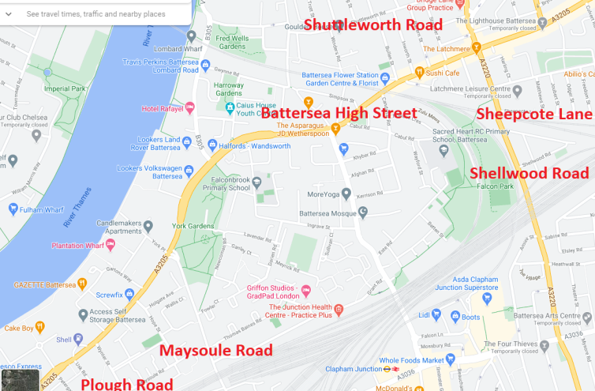When viewed at the level of neighbourhoods, the BLSW11 area is made up of diverse communities with possible different needs.
  2. Throughout 2021, BLSW11’s Community & Belonging Forum (CBF) has been consulting with local residents about specific local concerns. Looking at areas that lie outside of the BLSW11 central corridor of Falcon Road (admittedly an arbitrary distinction), CBF has had contributions from people living in:
* Plough Road
* Maysoule Road
* Battersea High Street
* Sheepcote Lane
  1. The areas around Shellwood Road and Shuttleworth Road have been targeted for better engagement.
  2. While there is local information on most of the indicators cited in this report there is a dearth of information (qualitative) that reflects the needs and lived experiences of people in specific areas.

## Digital Exclusion

**Key Findings & Issues**

* COVID-19 has brought to the fore the importance of digital exclusions.
* Many people in BLSW11 and Battersea do not have access to information technology and many lack training in its use.
  1. The COVID-19 pandemic brought to the fore the importance of information technology. Many social service operations (housing benefits, universal credits, etc.) are already based on online systems.
  2. During the first lockdown many organisations had to adopt different approaches to service delivery and organisational management, using digital means to meet, network, run events, deliver online training, and communicate with users via social media.
  3. For the BLSW11 area, digital inclusion is relatively low across all cohorts.

**Access and Use[[36]](#footnote-36)**

* 1. Notably, “Passive and Uncommitted Users” are significantly more evident in BLSW11 than the rest of Wandsworth.
  2. The low take up of information technology for BLSW11 is reinforced by a recent survey of Wandsworth residents, which showed that over 40% of respondents lacked confidence in using digital technology.[[37]](#footnote-37)

**Confidence in Using Digital Technology**

* 1. Of all the respondents, 74% had had no training, while 41% had no internet access.

**Summary**

* 1. In response to the evidence of digital exclusion evidenced from the COVID-19 pandemic, the Katherine Low Settlement initiated a digital inclusion network that has been meeting regularly to look at ways of addressing the needs of those most disadvantaged in Battersea (and Wandsworth).

## Community Needs

* 1. In terms of overall community needs, on most measures, BLSW11 fares poorly when compared to the rest of Wandsworth.

**Community Need Indices[[38]](#footnote-38)**

* 1. In the domains of “Active and Engaged”, “Community Needs” and “Connectedness Score”, BLSW11 is less well-placed compared with the rest of Wandsworth and London.
  2. The one domain where BLSW11 does better is on the “Civic Assets score”, which measures the presence of key community, civic, educational and cultural assets in close proximity to the area.[[39]](#footnote-39)

**Summary**

* 1. With poor ‘connectedness’ but good community infrastructure, the evidence suggests that increasing measures that improve connectedness (befriending, mentoring, intergenerational projects, community associations and events, etc.) may contribute to building social capital.

## 16. Gaps in Information and Knowledge

16.1 In preparing this community needs assessment it became evident that there are many probable ‘needs’ in BLSW11 and Battersea that lack adequate data or which have never been researched.

16.2 **Carers** – we know that there are approximately 1,000 Carers living in Latchmere (and that this is comparable with the rest of Wandsworth)[[40]](#footnote-40) but we lack robust information about their concerns and challenges.

16.3 **LGBTQ+** - the interests of LGBTQ+ people are reasonably well represented at a National and Regional level, but may be less well understood or recognised locally. (Stonewall – [www.stonewall.org.uk](http://www.stonewall.org.uk) ; Opening Doors London, [www.openingdoorslondon.org.uk](http://www.openingdoorslondon.org.uk) )

16.4 **Refugees** – the number of refugees/asylum seekers in Wandsworth is unknown but according to the Migration Observatory in December 2020, 70,000 were waiting on the outcome of their asylum claim (migrationobservatory.ox.ac.uk)

16.5 **Transitional groups** – young people moving from a Care setting to independent living, or from the criminal justice system into care, or the more traditional moves between schools/higher education, or into employment – bring many challenges that can have a long lasting impact. But for BLSW11 and Battersea the numbers affected are unknown.

16.6 **European Citizens** – our population data suggests that a significant proportion of inward migration has come from Europe and probably Eastern Europe, which, post-Brexit, may present particular problems for people living in BLSW11 from these communities.

16.7 **Areas that are under-presented** – there are neighbourhoods in BLSW11 and Battersea that lack representation or have no voice (no residents associations/area associations or community groups).

## Appendix 1: Methodological Issues

Compared with 2012/13, when BLSW11 began its first Area Profile, the quantity and quality of information available at a local level has significantly improved.

The Local Insight database alone holds information in 15 categories, including 1208 indicators at five levels.

In this report, the focus has been on sourcing evidence that might help an organisation with community development objectives to define its priorities and inform its strategy. To this extent, what has been selected for attention inevitably reflects a degree of bias or preference.

There is an inevitable bias too about how some of the data is interpreted whereby the inferences drawn may be contestable or open to alternative conclusions.

**Local Insight**

However, most of the data in this report comes from the Local Insight facility established by the Local Trust with the specific aim of supporting Big Local Areas.

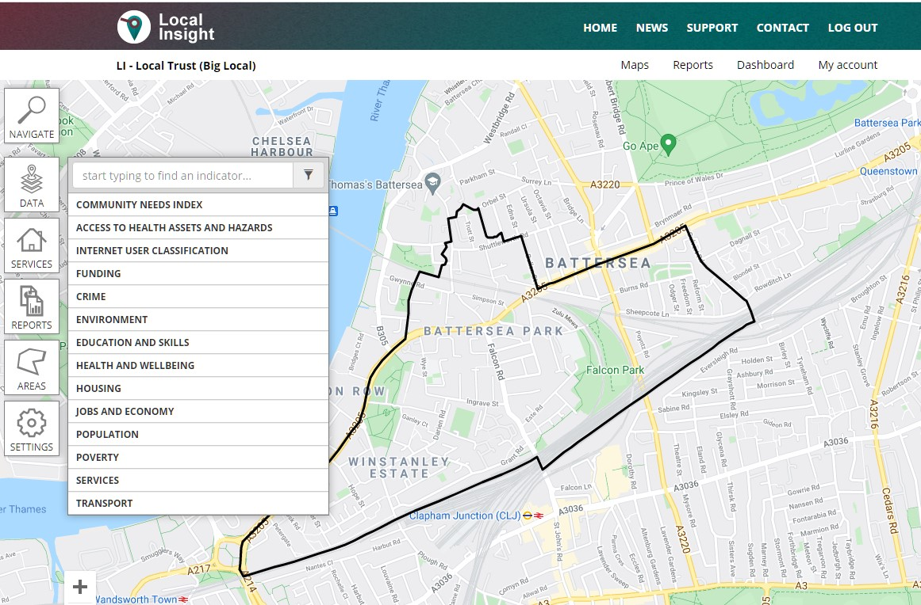

**Local Insight**

Local Insight Report (BLSW11)

<https://www.biglocalsw11.co.uk/research/>

Local Insight – Sources

<https://local.communityinsight.org/map/> (Password needed)

**Quantitative and Qualitative Issues**

While this report is based on quantitative data it has been informed through consultations with:

* The Community & Belonging Forum
* Battersea Befrienders
* Battersea Elders Forum
* The BAME Mental Health Network
* Wandsworth Community Empowerment Network
* Katherine Low Settlement
* Caius House
* Carney’s Community
* Battersea Mosque
* Providence House
* The South West London Clinical Commissioning Group

It is hoped that, looking ahead, the findings of this report will prompt further qualitative research into the key themes of isolation, loneliness and mental health, with a specific emphasis on young people, older people, single parents and BAME communities in Battersea.

For enquires about this report or suggestions on further research areas/themes contact David Stone [david@biglocalsw11.co.uk](mailto:david@biglocalsw11.co.uk) or 07950013153

## Appendix 2: Maps, BLSW11 & Battersea

BLSW11

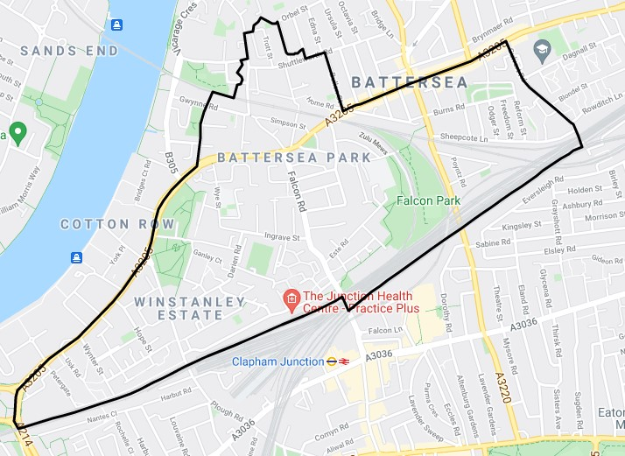

BLSW11 & Battersea

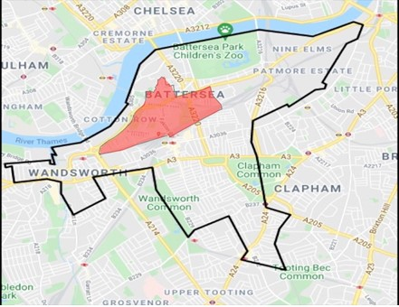

## Appendix 3: Data Sources

**COVID-19 Impact Research, National, Regional, Thematic and Local Data**

**Office for National Statistics**

Indicators from the Opinions and Lifestyle Survey covering the period 27 to 31 January 2021 to understand the impact of the coronavirus pandemic on people, households and communities in Great Britain (Release date 5th February 2021)

<https://www.ons.gov.uk/peoplepopulationandcommunity/healthandsocialcare/healthandwellbeing/bulletins/coronavirusandthesocialimpactsongreatbritain/latest>

**UK Research & Innovation**

<https://www.ukri.org/our-work/tackling-the-impact-of-covid-19/researching-the-impact-of-coronavirus/>

Specific Reports On:

Over 50s

Self-employed

Poor Housing

BAME workers in the NHS

Mental Health

**The Health Foundation (Public Health England)**

COVID-19 Impact Study

<https://www.health.org.uk/what-we-do/a-healthier-uk-population/mobilising-action-for-healthy-lives/covid-19-impact-inquiry>

**Government**

COVID-19 Impact on Health

<https://www.gov.uk/government/publications/wider-impacts-of-covid-19-on-health-monitoring-tool/wider-impacts-of-covid-19-on-health-summary>

COVID-19 Impact on the Economy

<https://www.ons.gov.uk/economy/grossdomesticproductgdp/articles/coronavirusandtheimpactonoutputintheukeconomy/october2020>

**GLA**

<https://data.london.gov.uk/dataset/socio-economic-impact-of-covid-19>

#### [Covid-19 socio-economic impact briefing August 2020.pdf](https://data.london.gov.uk/download/socio-economic-impact-of-covid-19/afb369bc-b270-4305-8321-9a3da0279069/Covid-19%20socio-economic%20impact%20briefing%20August%202020.pdf)

#### [Rapid Evidence Review - Inequalities in relation to COVI…](https://data.london.gov.uk/dataset/rapid-evidence-review-inequalities-in-relation-to-covid-19-and-their-effects-on-london)

#### Greater London Authority (GLA)

**MIND**

<https://www.mind.org.uk/search-results?q=Covid+research#stq=Covid%20research&stp=1>

**Disability**

<https://www.accessandmobilityprofessional.com/survey-reveals-impact-of-covid-on-disabled-peoples-activity-levels/>

**NCVO**

The Impact of COVID-19 on the Voluntary Sector

<https://publications.ncvo.org.uk/impact-covid-19-voluntary-sector/>

**BAME**

<https://committees.parliament.uk/work/318/unequal-impact-coronavirus-and-bame%20-people/>

**Young People**

<https://youngminds.org.uk/about-us/reports/coronavirus-impact-on-young-people-with-mental-health-needs/>

**Older People**

<https://www.ageuk.org.uk/information-advice/coronavirus/>

<https://www.ageuk.org.uk/latest-press/articles/2020/10/age-uk--research-into-the-effects-of-the-pandemic-on-the-older-populations-health/>

**Local (Wandsworth, Battersea, BLSW11)**

Wandsworth Working in Partnership with the VCS – COVID-19 Survey

<https://www.biglocalsw11.co.uk/research/>

Statement of Community Involvement, Winstanley and York Road Estate Regeneration (2018) (Available from DS)

Joint Strategic Needs Assessment (JNSA) (2021 drafts)

* People
* Vulnerable Groups
* Start Well
* Live Well
* Age Well

[**https://democracy.wandsworth.gov.uk/documents/s84618/JSNA.pdf**](https://democracy.wandsworth.gov.uk/documents/s84618/JSNA.pdf)

**Data Wand (**[**https://www.datawand.info/**](https://www.datawand.info/)**),** largely based on the 2011 Census.

DataWand is a free and open website designed so that users can easily access local data relevant to the London Borough of Wandsworth. This site brings together a collection of data from nationally recognised sources, across several themes to provide a full overview of the borough and how it compares locally and nationally.

**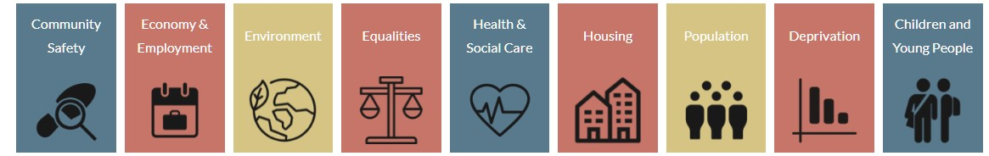**

**Big Local SW11**

State of the Sector (BLSW11) Report

<https://www.biglocalsw11.co.uk/research/>

**Partnership Support and Sources**

This report has been helped by the collaboration and support provided by our partner organisations, in particular:

* Carney’s Community provided the results of their research into the needs/issues/challenges facing young people
* Katherine Low Settlement, Elders programme kindly provided the results of their survey of older people
* LB Wandsworth provided the results of their survey of digital exclusion in Wandsworth
* LB Wandsworth Children’s Services – Locality Profile July 2021
* Wandsworth Community Empowerment Network advised on BAME issues
* The Joint Venture (LB Wandsworth/Taylor Wimpey) provided a summary of their latest residents needs survey

**Pending**

Battersea Together – 8th October 2021

## Appendix 4: Community Needs - Definitions

Community Needs Index: Active and Engaged Community score

The Community Needs Active and Engaged Community score measures the levels of third sector civic and community activity and barriers to participation and engagement. It shows whether charities are active in the area and whether people appear to be engaged in the broader civic life of their community. The Active and Engaged Community domain forms part of the Community Needs Index that was developed to identify areas experiencing poor community and civic infrastructure, relative isolation and low levels of participation in community life. The index was created by combining a series of 19 indicators, conceptualised under three domains: Civic Assets, Connectedness, and Active and Engaged Community. A higher score indicates that an area has higher levels of community need.

**Date:** *2019*

**How often updated:** *Irregular (September 2019)*

**Source:** *Oxford Consultants for Social Inclusion (OCSI) and Local Trust (https://localtrust.org.uk/insights/research/left-behind-understanding-communities-on-the-edge/)*

#### Community Needs Index: Civic Assets score

The Community Needs Civic Assets score measures the presence of key community, civic, educational and cultural assets in close proximity to the area. These include pubs, libraries, green space, community centres, facilities that provide things to do often, at no or little cost, which are important to how positive a community feels about its area. The Civic Assets domain forms part of the Community Needs Index that was developed to identify areas experiencing poor community and civic infrastructure, relative isolation and low levels of participation in community life. The index was created by combining a series of 19 indicators, conceptualised under three domains: Civic Assets, Connectedness and Active and Engaged Community. A higher score indicates that an area has higher levels of community need.

**Date:** 2019

**How often updated:** Irregular (September 2019)

**Source:** Oxford Consultants for Social Inclusion (OCSI) and Local Trust (https://localtrust.org.uk/insights/research/left-behind-understanding-communities-on-the-edge/)

#### Community Needs Index: Connectedness score

The Community Needs Connectedness score measures the connectivity to key services, digital infrastructure, isolation and strength of the local jobs market. It looks at whether residents have access to key services, within a reasonable travelling distance. It considers how good public transport and digital infrastructure are and how strong the local job market is. The Connectedness domain forms part of the Community Needs Index that was developed to identify areas experiencing poor community and civic infrastructure, relative isolation and low levels of participation in community life. The index was created by combining a series of 19 indicators, conceptualised under three domains: Civic Assets, Connectedness, and Active and Engaged Community. A higher score indicates that an area has higher levels of community need.

**Date:** 2019

**How often updated:** Irregular (September 2019)

**Source:** Oxford Consultants for Social Inclusion (OCSI) and Local Trust (https://localtrust.org.uk/insights/research/left-behind-understanding-communities-on-the-edge/)

#### Community Needs Index: Community Needs score

The Community Needs Index was developed to identify areas experiencing poor community and civic infrastructure, relative isolation and low levels of participation in community life. The index was created by combining a series of 19 indicators, conceptualised under three domains: Civic Assets, Connectedness, and Active and Engaged Community. A higher score indicates that an area has higher levels of community need.

## Appendix 5: Defining Digital Use

#### Internet User Classification: Passive and Uncommitted Users

Shows the proportion of people living in LSOAs classified as Passive and Uncommitted Users in the 2018 Internet User Classification (IUC). The Passive and Uncommitted Users group comprises individuals with limited or no interaction with the internet. They tend to reside outside city centres and close to the suburbs or semi-rural areas. Members of this Group have few distinctive characteristics in conventional socioeconomic terms, albeit higher levels of employment in semi-skilled and blue-collar occupations. Individuals are rarely online, and most commonly report that they use the internet once a week or less. Access to broadband is well below average, and for those online, there is slight preference for access via smartphones. The internet is typically used for social networks, gaming and some limited online shopping. The IUC is a bespoke classification that describes how people living in different parts of Great Britain interact with the internet.

**Internet User Classification: Youthful Urban Fringe**

Shows the proportion of people living in LSOAs classified as Youthful Urban Fringe in the 2018 Internet User Classification (IUC). The Youthful Urban Fringe often resides at the edge of city centres and are often young and drawn from ethnic minorities. These include a mixture of students and other young urbanites living in informal households, often at the edges of materially deprived communities. Access through desktop devices is particularly low, suggesting a young and mobile profile of individuals. Access to broadband is average, possibly due to other modes of access, such as internet usage in public places. The levels of internet engagement are average overall, with high levels of social media usage but low patronage of online retailing.

#### Internet User Classification: e-Professionals

Shows the proportion of people living in LSOAs classified as e-Professionals in the 2018 Internet User Classification (IUC). The e-Professionals Group has high levels of internet engagement, and comprises fairly young populations of urban professionals, typically aged between 25 and 34. They are experienced users and engage with the internet daily and in a variety of settings. While communication and entertainment activities are very common, they tend to favour entertainment, such as gaming, more than social networks. They also carry out a significant portion of shopping activities online, particularly for non-groceries, and they use a variety of devices and methods to access the internet. This group is ethnically diverse, with a very strong representation of white, non-British populations. They are well-qualified and have a very high availability of internet at work. This group tends to be found in residential areas abutting city centres or in affluent suburbs.

#### Internet User Classification: e-Veterans

Shows the proportion of people living in LSOAs classified as e-Veterans in the 2018 Internet User Classification (IUC). The e-Veterans Group represents affluent families, usually located within low-density suburbs, with populations of mainly middle-aged and highly qualified professionals. They are more likely to be frequent and experienced users of the internet, having the second highest levels of internet access at work after the e-Professionals users. They engage with the internet using multiple devices and in a variety of ways. They are fairly mature users and, as such, they have higher levels of engagement for information seeking, online services and shopping, but relatively less so for communication and entertainment, particularly social networks or gaming.

1. Unless specifically cited the tables and charts in the report come from the Local Insight resource: <https://local.communityinsight.org> [↑](#footnote-ref-1)
2. Some of the changes arise from new data sources [↑](#footnote-ref-2)
3. 2011 Census was for Latchmere Ward, BLSW11 includes a small part of St Mary’s Ward [↑](#footnote-ref-3)
4. <https://www.health.harvard.edu/newsletter_article/the-health-benefits-of-strong-relationships>; <https://www.thelancet.com/journals/lanpub/article/PIIS2468-2667(19)30253-1/fulltext> [↑](#footnote-ref-4)
5. <https://www.oecd.org/insights/37966934.pdf> ; <https://www.ons.gov.uk/peoplepopulationandcommunity/wellbeing/bulletins/socialcapitalintheuk/2020> [↑](#footnote-ref-5)
6. Challenges for society, the community, for BLSW11 and its Partners [↑](#footnote-ref-6)
7. Community Needs and Community Assets here refer to the comparative level of, or lack of, community centres, organised groups, charities, associations, or activities that bring people together [↑](#footnote-ref-7)
8. https://www.civilsociety.co.uk/news/charities-face-closure-as-sector-set-to-lose-4bn-over-12-weeks.html [↑](#footnote-ref-8)
9. IFS <https://ifs.org.uk/publications/14827> “Are some ethnic groups more vulnerable to COVID -19” than others? [↑](#footnote-ref-9)
10. <https://ifs.org.uk/publications/14879> “Covid-19: the impacts of the pandemic on inequality” [↑](#footnote-ref-10)
11. <https://publichealthmatters.blog.gov.uk/2020/06/01/the-community-response-to-coronavirus-covid-19/>; <https://www.theguardian.com/society/2020/may/26/uk-volunteering-coronavirus-crisis-community-lockdown> [↑](#footnote-ref-11)
12. <https://journals.sagepub.com/doi/full/10.1177/1757913921994146>; [↑](#footnote-ref-12)
13. Some of the increase is because the BLSW11 area includes parts of St Mary’s Ward; the 15,200 figure was based on Latchmere only. Source: Local Insight [↑](#footnote-ref-13)
14. Shows the total flow of people moving in to the local area expressed as a rate per 1,000 resident population. Figures are based on GP patient register records. [↑](#footnote-ref-14)
15. For example, home ownership is more prevalent amongst people from an Asian background than (say) from a Caribbean one. [↑](#footnote-ref-15)
16. <https://www.birmingham.ac.uk/research/ptr/lived-religion-impact-society.aspx> [↑](#footnote-ref-16)
17. Poverty is defined as income at less than 60% of the median income (Department for Work and Pensions) [↑](#footnote-ref-17)
18. <https://cpag.org.uk/child-poverty/effects-poverty>, <https://www.bristol.ac.uk/poverty/definingandmeasuringpoverty.html> [↑](#footnote-ref-18)
19. The indicators shown do not reflect the full range available, but those where BLSW11 stands out. Other indicators show BLSW11 performing well according to other measures. [↑](#footnote-ref-19)
20. Small Area Mental Health Index. The SAMHI is a composite annual measure of population mental health for each Lower Super Output Area (LSOA) in England. The SAMHI combines data on mental health from multiple sources (NHS-Mental health related hospital attendances; the GP Patient Survey – Q34 Best describe your own health state today; prescribing data – antidepressants, QOF - depression; DWP - Incapacity benefit and Employment support allowance for mental illness) into a single index. A higher score indicates that an area is experiencing high levels of mental health need. [↑](#footnote-ref-20)
21. Overcrowding is defined as housing that does not have rooms appropriate for the number, age and sex of the residents. [↑](#footnote-ref-21)
22. Households are classified as overcrowded if there is at least one room fewer than needed for household requirements, based on the ‘occupancy rating’ taking into account peoples ages and relationships. [↑](#footnote-ref-22)
23. Source: <https://www.campaigntoendloneliness.org/the-facts-on-loneliness/>

    [↑](#footnote-ref-23)
24. The term *social capital* describes the characteristics of the relationships between people in communities. Some areas are rich in social capital, with multiple forms of interaction between people through neighbourhood associations, clubs, community groups, trusts, charities and strong kinships; others are poorer, with few opportunities for people to come together with share common purposes.

    Communities with strong social capital are better placed to deal with threats and take advantage of opportunities than those where social capital is weak. Social capital is essentially about how people interact and relate to each other. [↑](#footnote-ref-24)
25. Taken from LB Wandsworth’s Children’s Services Locality Profile (Battersea Cluster), July 2021. [↑](#footnote-ref-25)
26. <https://assets.publishing.service.gov.uk/government/uploads/system/uploads/attachment_data/file/925329/State_of_the_nation_2020_children_and_young_people_s_wellbeing.pdf> [↑](#footnote-ref-26)
27. <https://www.standard.co.uk/news/education/almost-half-london-s-youth-clubs-face-closure-b932377.html> [↑](#footnote-ref-27)
28. <http://londonyouth.org/wp-content/uploads/2018/05/Hidden-in-Plain-Sight-Web-Version.pdf> [↑](#footnote-ref-28)
29. <https://www.employment-studies.co.uk/resource/unequal-crisis-impact-pandemic-youth-labour-market> [↑](#footnote-ref-29)
30. Although these comments/observations derive from a small sample of young people, they do resonate with broader research findings: see <https://www.russellwebster.com/what-young-people-think-about-the-police/> and <https://www.childrenscommissioner.gov.uk/report/children-and-young-peoples-views-of-education-policy/> [↑](#footnote-ref-30)
31. https://www.nhs.uk/mental-health/feelings-symptoms-behaviours/feelings-and-symptoms/loneliness-in-older-people/ [↑](#footnote-ref-31)
32. The language and categorisation of different groups may itself be an important issue in the way we talk about each other and how this may reinforce stereotypes. [↑](#footnote-ref-32)
33. <https://www.theguardian.com/society/2019/jan/29/more-than-half-young-people-jail-are-of-bme-background>; [↑](#footnote-ref-33)
34. Some arguments focus on macro-economic factors, skills and qualifications; others on cyclical factors or structural reasons: <https://www.thebalance.com/long-term-unemployment-what-it-is-causes-and-effects-3305518#main-causes-of-long-term-unemployment> [↑](#footnote-ref-34)
35. <https://assets.publishing.service.gov.uk/government/uploads/system/uploads/attachment_data/file/355792/Briefing8_Green_spaces_health_inequalities.pdf> [↑](#footnote-ref-35)
36. See Appendix 5: Defining Digital Use [↑](#footnote-ref-36)
37. Wandsworth’s residents digital survey (2021, with 305 responses) [↑](#footnote-ref-37)
38. On each measure, the higher the score the greater the ‘need’. [↑](#footnote-ref-38)
39. See Appendix 4 for a full description of each measure of Community Need [↑](#footnote-ref-39)
40. LB Wandsworth DataWand: <https://www.datawand.info/health-and-social-care/report/view/c69454d7bdb344f88fb6ab2151190806/E01033093/> [↑](#footnote-ref-40)