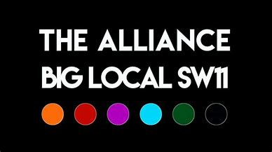
Battersea Together
– Battersea Fights Back!
Summary of the Battersea Together Event
8th October 2021 at Caius House, 10:00am-3:00pm

The fourth in a series of partnership development and networking events building coalitions and communities of place and interest in Battersea; attended by 70 people ‘live’ plus 20 ‘online’.

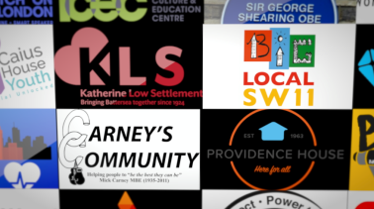
- Community Stories
The first session saw presentation of 28 organisations and their responses to the Covid-19 Pandemic, demonstrating the resilience, fortitude and immense power of collective action in the most challenging of circumstances!
We witnessed very moving accounts of how organisations, community groups and volunteers, facing lock-down, funding cuts and furlough, battled to support the most vulnerable in Battersea.
Here’s the link to the full presentation: https://www.youtube.com/watch?v=l8_x3ZgB6Zo&ab_channel=KeepsakeVideos
Key lesson: People Care, can mobilise and deliver effective action!

- Community Conversations
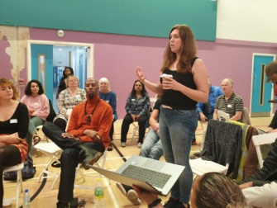
The mid-morning session saw everyone engaging in a debate about the challenges facing Battersea, from poverty, unemployment, housing to isolation, loneliness and mental health. Key barriers that hinder effective responses included poor infrastructure, institutional racism and a lack of long-term funding for the community voluntary sector.
Key Lesson: Long Term Strategic Action is needed!

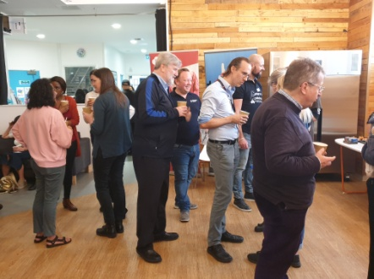
- Networking
During the lunch break people met face-to-face, for some for the first time in nearly two years, to shared experiences and exchange contact details. Groups that may have felt uninformed about the Alliance got to meet the key players and new relationship were established.
Key Lesson: We need to meet more often!
- Workshops
In the afternoon a series of workshops based on 5 strategic themes saw intense debate and a close examination of the issues – write ups for each session can be accessed at Appendix 2 or follow the hyperlinks here:
- Arts & Culture
- Criminal Justice & Mentoring
- Families
- Information Technology & Education
- Elders & Organisational Support

- Plenary
The final session involved a summary of each of the workshops and a call to continue the dialogue.
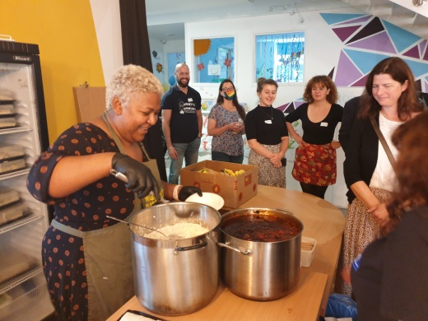
- Food!
Many thanks to Waste Not Want Not Battersea for providing the lunch and ensuring that any surplus food was used to support local people!

- Follow-up
Battersea Together – The Story Continues...

Building on outstanding examples of community led initiatives and partnership working presented at the Battersea Together event on the 8th October you are invited to continue the discussion and contribute to the development of follow-up actions here:

Theme Follow-up meeting

Arts & Culture 18th Nov - Providence House
Time: 10:00 -12:00
138 Falcon Road, SW11 2LW
Contact: Esther, 07445 983904, esther.providencehouse@gmail.com

Criminal Justice & Mentoring 9th Dec - Carney’s Community
Time: 10:00 -12:00
30 Petworth Street, SW11 4QW
Contact: George, 07513 384042, George@carneyscommunity.org
Families 20th Jan’22 - St Peter’s Battersea
Time: 10:00 -12:00
23 Plough Road, SW11 2DE
Contact: Charlie, 020 8050 2959, Charlie@stpetersbattersea.org.uk

Elders & Organisational Support 24th Feb’22 – KLS
Time: 10:00 -12:00
108 Battersea High Street, SW11 3HP
Contact: Aaron, 020 7223 2845, aaron@klsettlement.org.uk

Information Technology & Education 24th March’22 - Caius House
Time: 10:00 -12:00
2 Holman Road, SW11 3RL
Contact: Del, 07939 232088, del@caiushouse.org

- Contact
For General Enquiries about these sessions or the Battersea Alliance please contact: David at david@biglocalsw11.co.uk

Appendix 1: Community Stories from....

- Covid-19 Fund
- Waste Not Want Not Battersea
- Kambala Cares
- JCT
- Women of Wandsworth
- Wandsworth Food Bank
- Battersea Mutual Aid
- KLS Elders
- Battersea Angels
- Battersea Befrienders
- Sound Minds
- Battersea Youth Voice
- Carney’s Community
- Love to Learn
- Providence House
- FAST
- Power to Connect
- Dons Action Group
- Riverside Radio
- SWLLC
- Citizens Advice
- Elays
- Battersea Volunteering
- Maysoule Road Community Group
- St Peter’s Battersea
- Karma Yoga
- Battersea Mosque
- George Shearing Centre

Appendix 2 – Workshops

Arts & Culture
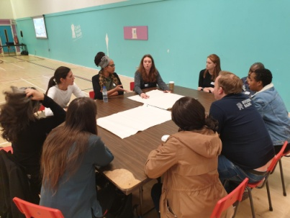
What role do arts and culture play in the future success of our community? (Battersea)
- Increased access to education for people who learn / communicate differently
- Empower – enable people to have an increased voice
- Give people opportunity to identify, develop and share different skills and talents
- Give opportunities
- Offer transferable skills
- Support positive mental health and wellbeing
- Increase community cohesion
- Enable different points of view to be expressed reducing conflict – help people communicate different perspectives
- Encourage and enable intercultural exchange
- Facilitate story telling
- Entertaining and Fun
- Build confidence and self esteem
- Give a physical voice and platform of expression for those who may go unheard
- Celebrate culture, diversity and foster feelings and attitudes of respect and understanding difference
- Enrich experiences and develop greater world view
- Able to express who you are – unique talent
- Drama and music as avenues of learning
- A communication tool that can be made accessible to all
- Therapeutic tool
- Brings communities together
- Intergenerational
- Help reflect Battersea’s diverse ‘culture’ (What is Battersea)
- Able to spot and invest in local talent – raise up and inspire form within
- Deterrent to other more negative behaviours / routes
- Cultivates a sense of belonging and achievement
- Point of engagement which can lead to wider / deeper work
- Gives a sense of pride
- Connects people to their routes and history
- Connecting with identity and sense of self
- Creativity to find solutions
- Gives purpose
- Makes things beautiful
- Creates spaces that people are proud of and want to be / look after
- Alleviates boredom
- Increase socialisation and decreases isolation
- Enables representation of self – inspirational role models / representations in the arts that look like me
- Character building – patience, perseverance, perfecting/ honing a skill or talent – discipline and sense of self investment / development
- Deeply personal and part of being human / part of life

Challenges / Gaps / Barriers

- Economic inequalities
- Cultural barriers
- Elitism of the arts / lack of access
- Communication barriers
- Confusion around how to advocate for others
- Gate keeping of groups of communities and how to identify key people to build relationships with
- Lack of space and provision for the arts in the community and schools
- Lack of resources / funds for quality resources and services
- Lack of focus on the arts from leaders / people in power
- Undervaluing the arts and artists
- Lack of arts in education
- Recognition of arts / creativity as a form of education
- More focus on the benefits or art to support disabled people
- Lack of confidence / self belief
- Information, advice and guidance in relation to the arts / opportunities etc
- Keeping services / stimulation / opportunities consistent and sustainable
- Fear of the unknown
- Being able to be yourself in a safe space
- Audience – pressure pf performing
- Being able to appreciate art in the moment not having to have a tangible outcome – doing it for the experience
- Xenophobia , Racism, Sexism, Class
- Arts being perceived as an add on or luxury (Fluffy)
- Costs of transport for free attractions
- Covid Cuts
- Lack of consistent organisations running accessible programmes
- Lack of diverse / multi-cultural representation

Dreams for the future
- Accessible arts services for all
- Equal diverse representation
- Increased arts in school and as a form of education
- Increased value / change of perspective of arts and culture within mainstream society
- Campaigns to raise awareness of the issues / barriers
- Service redesign – using arts / creativity as a starting point
- More funding, opportunities, training
- Arts centres celebrating all types of art – multi arts community hubs
- Venues and resources to develop quality talent
- Recognition for artists as professionals - not expected to deliver for free – given a set minimum wage
- More arts spaces and places to express and be creative
- History to be taught to reflect truth and cultural diversity in order to change narratives and increase equality and sense of positive identity
- Having honest conversations through the arts
- Better understanding of disability needs
- Special artist status
- Multipurpose venues that integrate information and creativity
- More arts / crafts and performing arts workshops
- Arts seen as alternative form of education and therapy
- Accessible costs and in safe familiar spaces for people
- Better information about what’s already there
- Vision and funding secured for the long term
- Annual / regular events and shows that display arts and culture and bring the community together
- Library of instruments
- Skills / arts library
- Connecting to self
- Opportunities for young people to attain professional training and career success
- Linking talent and opportunities together

Criminal Justice & Mentoring
How do we imagine Battersea looking like in the future, if we were to improve our work with those in the criminal justice system (and those at risk of becoming involved), with more access to mentoring support?

The causes of crime in Battersea
- Long term impacts of education, isolation etc
- Experiences of trauma and PSTD
- Criminal justice system needs to be called out for criminalising behaviour of certain groups and not believing in rehabilitation…..only revenge and punishment
- Funding and long term funding for crime prevention is not available
- Society does not give people the opportunities to demonstrate their rehabilitation
- Not enough safe spaces where young people can hang out
- Not enough real life role models
- Negative image of young people portrayed by the media
- Social media causes more crime and knife crime
- Schools need to stop excluding and to be more open to different learning styles
- Not enough opportunities for people to be creative
- There needs to be better SEN recognition and assessment
- Businesses need to be a part of their community and provide job opportunities to those most in need (invite local businesses to next Battersea Together event)

The benefits of mentoring on crime levels and the community
- Mentee has access to a consistent and trusted adult
- Mentor feels like the have purpose and a sense of responsibility
- Opportunities to be open and express emotions
- Creates a sense of belonging
- Creates a “pay it forward” mentality within the community eg someone supported me when I was younger, so I will now support others.
- Creating connections and more options
- Improved self esteem and confidence (for both mentor and mentee)
- Unlocks potential and talent that lie in all young people
- Can help educate the community about those from other backgrounds
- Improved environment for businesses
- Creates conversations between different groups
- Changes perception on youth
- Makes them feel valued and not judged
- Creates a self-policing community
- People feeling safe which in turn reduces knife crime
- The creation of “a village to raise a child”
- Ability for people to recognise and demonstrate their own strengths (which in turn helps the community)
- More opportunities to achieve
- Heightened sense of belonging and safety
- Mentors feeling like they have a purpose

How to deliver mentoring to reduce crime
- It’s about developing relationships
- Has to be fluid and not time limited
- Outcome driven (but outcomes can simply be to have developed a positive relationship)
- Use real life role models, such as people who have had similar experiences to those being mentored
- However, can also use those from different classes and backgrounds to help both parties understand each other
- Mentors need to be from a variety of backgrounds and reduce the social divide
- Mental health support for both mentors and mentees (clinical supervision for mentors)
- Mentor has to be available at the same times as the mentee
- Mentor has to be a trusted adult, but not a jack of all trades eg, they need to have a good knowledge of other local services they could refer onto eg community mental health and counselling
- Good quality training needs to be available for mentors
- Good matching and relationships being built beforehand. This means potential mentors need to be available and visible in the mentees community, in order to build those relationships and create trust
- Good connection with schools and the community
- Need to be able to target multiple complex issues
- Look at the cause of mentees behaviour, not just the consequence
- Be non-judgemental
- It helps break the cycle in families where there has been intergenerational crime/violence
- Mentors need to also play the role of advocate for their mentee and support them to use their own voice
- Need to be available for when the young person is at their point of contemplating change (teachable moment).
- Would also need Family/parenting mentoring
- Needs to be clear boundaries (but not professional boundaries that social workers and probation have)

Families
Questions:
How do we imagine families thriving in Battersea?
What might families have to offer the wider community of Battersea?
Group 1:
- Fathers included (by the system). New fathers supported by other fathers
- Families to live in a house with garden
- Access to decent, safe play areas
- Community gardens where we can grow plants/veg
- More support for mothers to work (eg affordable childcare)
- Neutral family mediation in a regular place/time
- A fairer maintenance system (currently, Mums get more if the kids see Dad less)
- More financial education eg. Budgeting for families
- Housing – kids need space
- Families need to be able to stay in the area (affordable housing)

Group 2:
- Good schools & youth clubs
- Bring back SureStart – it was a council funded initiative, through children’s centres, where parents can go to connect with other parents and receive advice on struggles, a one stop shop on housing, CV writing, education, parenting etc
- Good education and activities outside of school
- Feeling safe - in a neighbourhood, for women/families, no knife crime
- Spaces used for connection
- Dads more involved and expected to be present
- Families staying in Battersea in affordable housing
- Families offer stability and belonging: you invest where you feel like you belong

Group 3:
- Regular community events, learning from each other
- Intergenerational activities
- Kids outside, running around, off their devices
- Teaching/learning life skills eg. Cooking
- Adult learning & education activities
- Skill swapping (intergenerational, practical agency)
- Cultural exchange & befriending
- Integrated families, living and working together in the community
- Families feeling safe like they belong
- Affordable childcare
- Families enjoying themselves together, frequent events, communities having fun
- Modelling service to the community

Group 4:
- Families supporting each other
- Greater safety, trust in the community - ‘A village’
- Shared spaces for families eg, parks, cafes, churches, libraries where kids can play, community centres / business spaces that can be rented cheaply
- Community together
- People knowing each other outside their own families
- Accessibility to other parts of the borough to meet your needs
- Feeling safe to move around the borough, having information and knowledge about where to go
- Greater integration & holistic activities for families
- Families offering skills & resources out to the community
- Skill swap

Group 5:

- Family redefined – recognising it comes in different shapes and sizes and cultures
- ‘Urban Families’ = who you choose to spend your time with
- Building stronger relationships
- Diversity within families
- Families connected into the community
- Fairly paid, economically healthy
- Time for families
- Affordable activities
- Affordable housing, the right size so families can stay here – enough space for growing families

Information Technology & Education

Special Educational Needs:
- Call for early identification of needs to help prevent problems later on
- Separating behaviour from undiagnosed SEN issues (has there been investigation into undiagnosed SEN needs prior to exclusions)
- Resourced therapies in schools to benefit the students
- Reduction in the time to get to diagnostic
Curriculum:
- Flexible educational system
- Importance of vocational qualifications and trades
- Investigations around new ways to test/examine/assess
- Links to careers and working life so the learning is valued
- Teaching to accommodate a variety of learning styles
- Focus on early years reading and writing
- A curriculum that is accessible for all – being aware of unconscious bias and institutional racism within education
- Looking at the benefits and issues with league tables and the ability for young people to fall through the gaps
- Large class sizes
Skills:
- Importance of teaching and developing soft skills in education
- Focus on personal development
- Importance for extra curricula development
Families:
- Strengthening relationships between schools and families – especially at a time when there are issues
- Parent support groups – Where they can go for independent advice and guidance/workshops
- Parent/family liaison with the schools
- Help with appeals
- Independent representation at the exclusion panel meetings
- Look at the process of exclusions

Mental Health:
- Support to improve mental health in young people
- Curriculum that looks at the young person as a whole taking into account background, beliefs, culture, etc
Voluntary Sector:
- Improved relationships with voluntary sector to support young people
- A school Plus model where the voluntary sector get involved to help with delivery

Elders & Organisational Support

Organisational Support in Battersea
There is a need for long-term investment in organizational support infrastructure in Battersea and across the borough. It could be a lynch pin to ensure everyone comes together regularly and builds partnerships. It could help with things like: sharing information, evidence/needs assessment, capacity building, training, bespoke support, campaigning, funding, digital inclusion and more.
Older People in Battersea
There is a strong need for increased support for older people in Battersea. There is an aging population (and for decades to come), more than a decade of austerity cuts, the recent pandemic and rising costs of social care are all contributing to rising isolation, loneliness and poor physical and mental health amongst older people in Battersea.
There was a strong sense that more dedicated services for older people (as well as investment/funding) delivered by local community organisations/charities/NHS/Council, as well as intergenerational or multi-generational work would really help support local older people (as well as others in the community). Get all parts of the community in supporting, helping and learning from each other. It ‘takes a village’ to support each other, using multi-use, accessible community spaces/hubs with transport.
We should look at different ways of being people together e.g. celebrations, forums, networks, parties, mentoring etc… as well as more traditional services.
We would value our elders more (their knowledge and experience), if as a community we were more in touch with them. And we need to recognise that different people need different types of support. Some older people don’t see themselves as old!
Examples included: the nursery situated in a care home in Tooting, or White City community centre in Shepherds Bush or shared residencies such as students living with older people. In France you have a tab that pays for your health care and when you die you pay it back from your estate.
Would also looked at no- or low-cost health care at home support, as well as home adaptations, safeguarding, and support that is culturally appropriate. As well as better pay for social care staff. To keep elders out of institutional care for as long as possible.

