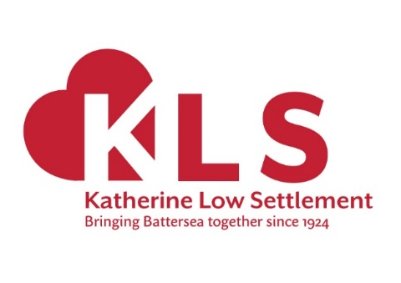

Katherine Low Settlement
Trustee recruitment Pack
Autumn 2021

Includes:
- A role description
- Information about how to apply
- Self-Declaration Form
- Equal Opportunities Form

Help & Further Information
If you’d like to talk about becoming a Trustee please contact KLS Director, Aaron Barbour on aaron@klsettlement.org.uk:

To apply please send the following to Aaron on the email above:
- A CV.
- A covering letter of no more than two sides of A4 explaining your interest and how you meet the person specification (with specific examples).
- A completed copies of the attached: Self-Declaration Form and Equal Opportunities From (see below).

We will assess applications as they come through.
Good luck!

Katherine Low Settlement
108 Battersea High Street, London, SW11 3HP
020 7223 2845
www.klsettlement.org.uk

Katherine Low Settlement Ltd is a registered charity no. 1081248, and a company limited by guarantee no. 3814833
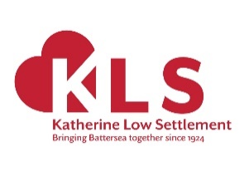
Role Description
Title: Trustee
Position: 3-year term
Salary: This a voluntary role. Reasonable travel expenses will be covered.
Hours: 2-3 hours per month incl. 5 main meetings per year, and away day and AGM
Responsible to: Chair of Trustees
Part of: Board of Trustees
Location: 108 Battersea High Street, London SW11 3HP (and work from home)

We’re looking for new volunteer Trustees to join our governing Board of Trustees.
Our Trustees find being a member of the board a rewarding experience where they get the opportunity to contribute to, shape the direction of, and oversee the governance of a long established and dynamic organisation. It’s an opportunity to give back to Battersea and the wider Wandsworth communities by using their skills and experience in another setting. They are a committed and passionate group. This is reflected in their meetings being engaging and serious fun.
We’d very much like to hear from you if you’re interested in joining us at this exciting time in our history.
- About Katherine Low Settlement
Katherine Low Settlement is a much-loved, busy charity that has been at the heart of the community in Battersea, South West London, since 1924. With a few staff and a lot of volunteers, we run a range of our own community services, we campaign for social change and we support other charities and communities to thrive.
We support children, young people and their families, older people, women and refugees and newly-arrived communities. Our building is used for community activities and events by over 500 people a week, and our rooms are available for hire at affordable rates. KLS is funded from supporters, trusts and foundations which enable us to achieve our goal to reduce poverty and isolation and bring Battersea together.
The charity has gone from strength to strength in the past decade under the leadership of our Director, Aaron Barbour. Having made great strides in achieving its strategic goals for 2017-21 (https://www.klsettlement.org.uk/about-us/strategy-2017-2021/), Trustees are working to develop a post-Covid strategy for 2022-25, building on the experience of the pandemic and the needs which have emerged while continuing to deliver its historic services both within and beyond the building itself.
The Settlement is situated on Orville Street and Battersea High Street and aims to serve the communities of SW11 and SW8, which includes areas of significant deprivation alongside some of the most prosperous neighbourhoods in the country. Its vision is to bring people together, to discover a common humanity in the process and to work together for some of the most vulnerable people in London.
Visit: www.klsettlement.org.uk
- The Board of Trustees
The Board of Trustees is the legal guardian of Katherine Low Settlement to ensure that KLS complies with its governing document (Memorandum and Articles of Association), charity law, company law and any other relevant legislation or regulations.
The Board of Trustees is responsible for directing the Settlement’s strategy and vision, for overseeing the work of its Director and Staff, and for settling policy, administering its finance and offering advice and support in the delivery of services. The board is currently made up of seven serving members, and has vacancies for up to three new Trustees, to a maximum of ten. Trustees are appointed by the Annual General Meeting for a period of three years, renewable my mutual agreement.
Gaps we’re looking to fill
The Trustees have identified gaps in its membership in terms of experience of community service/social work, fundraising, property and general management, and the voice of Settlement members. The board also recognises that it lacks diversity, particularly in representation by UKME/Global Majority Heritage people, younger people and those with disabilities.
- Key Responsibilities of Trustees
Trustees are expected to:
- Formulate and review regularly the strategic aims of the Settlement in accordance with its legal objects, and to ensure the policy and practices of the Settlement are in keeping with its aims.
- Monitor the performance of the charity against the agreed strategic aims.
- Ensure that the Settlement functions within the legal and regulatory requirements of a charitable organisation and strives to achieve best practice.
- Act as guardians of the charity’s assets, tangible and intangible, taking all due care over their security, deployment and proper application.
Within that broad responsibility, shared among the Trustees, the main tasks and accountabilities include:
- Formulating and reviewing strategic aims
- Ensure the Settlement has a clear vision, mission and strategic plan, and that there is a common understanding of these by Trustees and management.
- Work with management to formulate the business, operational and other plans necessary to support the vision, mission and strategic objectives.
- Agree and review the Director’s annual and longer-term objectives, to ensure that these support the vision, mission and strategic priorities.
- Agree policies which support the vision, mission and strategic priorities of the Settlement, and monitor their implementation.
- Follow best practice as recommended by the Charity Commission.

- Monitoring Performance
- Appoint the Director and ensure there is appropriate investment in their professional development.
- Agree the method for measuring objectively the progress of the Settlement in relation to its vision, mission and strategic priorities, business plans and annual targets, and to receive regular reports from the Chief Executive and senior staff on the performance of the Settlement.
- Ensure that the views of members on the Settlement’s performance are regularly gathered and considered by the Board.
- Hold the Director to account for the management and administration of the Settlement.
- Ensure that the Director receives regular, constructive feedback on their performance in managing the Settlement and in meeting annual and longer term goals.

- Legal and Regulatory Compliance
- Ensure that the Settlement complies with all legal and regulatory requirements.
- Has a sound grasp and awareness of its duty of care in safeguarding and that policy and practice are aligned to make the Settlement a safe place for members, especially children and vulnerable adults.
- Understand the rules and constitution that govern the Settlement, and to review the effectiveness of such rules and constitution periodically.
- Agree the levels of delegated authority, whether to the Director, the Chair, Vice-Chair & Treasurer of the Board, or to other groups or individuals.

- Guardians of the Settlement’s Assets
- Ensure that the Settlement has satisfactory control systems and procedures for holding in trust for the beneficiaries all monies, property and other assets.
- Ensure that monies which are invested on behalf of the Settlement are well-managed, within the constraints of the law and ethical and other policies laid down by the Board.
- Ensure that the major strategic and operational risks to which the Settlement is exposed are reviewed annually and that systems have been established to mitigate these risks.
- Ensure that the income and property of the Settlement are applied for the purposes set out by law and for no other purpose, and with complete fairness between people who are eligible to benefit.
- Ensure that intangible assets such as organisational knowledge and expertise, intellectual property and the Settlement’s good name and reputation are properly safeguarded.

- Promotion of the Settlement and Engagement with Stakeholders
- Be prepared to act as an ambassador for the Settlement when asked to by the Director or Chair of Trustees, and to work within an agreed brief.
- Attend events as an ambassador for the Settlement, to network and promote the work of the Settlement.
- Seek at all times to raise awareness of the work of the Settlement to potential beneficiaries.
- Assist with fundraising and awareness-raising through appropriate speaking and networking events, with support and training as appropriate.

- Recruiting Trustees with particular experiences
As part of a regular process of self-audit, the Trustees have identified a particular need to recruit Trustees with experience of:
- Community service – specific understanding of issues such as disability, discrimination, elders, refugees, adult social care, to complement and challenge the plentiful expertise within the staff.
- Fundraising – from the perspective of either charitable trusts or high net worth individuals or both, to help maximise our chances of success in fundraising activities.
- Lived experience - Ensuring the perspective of volunteers, members and alumni is represented in decision making. The Trustees have agreed to seek potential Trustees with this background from within its existing networks.
Although the Board is very effective, it lacks significant diversity, which diminishes its capacity to be even more effective. The Trustees would therefore particularly welcome interest from those from UKME/Global Majority Heritage backgrounds, younger people and people with disabilities, all of which are under-represented on the Board.
- Person Specification
Expressions of interest are invited, in writing, with examples of experience in the areas below:
Skills and Experience | Essential /  Desirable
Willingness to devote the necessary time and effort | E
Ability to contribute to the strategic vision and direction of KLS | E
Ability to work as an active and vocal part of the Trustee board | E
Effective communicator – both verbal and written | E
Willingness to be available to staff for advice and enquiries | E
Committed to KLS’s mission, vision and values and its work | E
Knowledge of Battersea / Wandsworth | E

No prior experience is needed. Full training and support will be given.

- Further Information
- Katherine Low Settlement is committed to equal opportunities.
- All offers to volunteer at Katherine Low Settlement are subject to two satisfactory references, which is standard KLS policy applicable to all roles. KLS may ask for an enhanced DBS check.
- You will adhere to matters of confidentiality concerning this role and the KLS team.
- An induction is given. This includes sharing KLS policies and procedures relevant to each post.

- Application Process
To express interest, please email the Director, Aaron Barbour at aaron@klsettlement.org.uk with:
- A CV.
- A covering letter of no more than two sides of A4 explaining your interest and how you meet the person specification (with specific examples).
- A completed copies of the attached: Self-Declaration Form and Equal Opportunities From (see below).

We will assess applications as they come through.
Good luck!

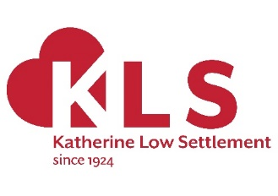
Katherine Low Settlement Self-Declaration and Disclosure Form
Private and Confidential

All information will be treated as confidential and managed in accordance with data protection legislation and guidance. You have a right of access to information about you under the Data Protection Act 1998.

Name:

Address and postcode:

Have you ever been known to any Children’s and/or Adult Services department as being a risk or potential risk to children and/or vulnerable adults? |  |  | YES / NO  (if Yes, please provide further information below):
Have you been the subject of any disciplinary investigation and/or sanction by any organisation due to concerns about your behaviour towards children and/or vulnerable adults? |  |  | YES / NO  (if Yes, please provide further information below):
Confirmation of Declaration (tick box below)
 | I agree that the information provided here may be processed in connection with recruitment purposes and I understand that an offer of employment may be withdrawn or dismissal may result if information is not disclosed by me and subsequently come to the organisation’s attention.
 | In accordance with KLS’s procedures, if required, I agree to undertake a DBS check and/or provide a valid DBS certificate and consent to the organisation clarifying any information provided on the disclosure with the agencies providing it.
 | I agree to inform KLS within 24 hours if I am subsequently investigated by any agency or organisation in relation to concerns about my behaviour towards children, young people and/or vulnerable adults.
 | I understand that the information contained on this form, the results of the DBS check and information supplied by third parties, may be supplied by KLS to other persons or organisations in circumstances where this is considered necessary to safeguard other children and/or vulnerable adults.
Signature:
Print name:
Date:

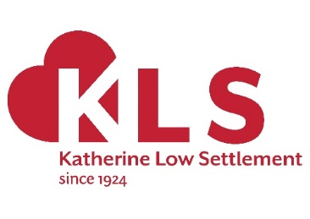
Katherine Low Settlement Equal Opportunities Monitoring Form

KLS want to make sure that it is an equal opportunities employer in practice, which is why we want to monitor our recruitment procedures. By completing this form, you are helping us improve our equal opportunities practice. We will separate this part of the form from the application form. It will not form part of the selection process. All information will be held confidentially.

Please tick the appropriate boxes:

- How would you describe your gender?
Male □ Female □ Transgender □ Prefer not to say □

- What age group do you belong to?
16-24 □ 25-34 □ 35-44 □ 45-54 □ 55-64 □ over 65 □
Prefer not to say □

- How would you describe your sexuality?
Heterosexual/straight □ Gay man □ Gay woman/lesbian □
Bi-sexual □ Prefer not to say □

- Do you consider that you have a disability?
Yes □ No □ Prefer not to say □

- Do you have a disability, as defined by the Disability Discrimination Act?
Yes □ No □ Prefer not to say □ Don’t know □

- Do you consider that you have a long-term health problem?
Yes □ No □ Prefer not to say □

- How would you describe your religion or belief?
My religion or belief is _____________________________________________________
I have no religion or belief □ Prefer not to say □

- How would you describe your nationality?
Please describe___________________________________________________________
Prefer not to say □

- How would you describe your ethnic origin?
Please describe ___________________________________________________________
Prefer not to say □

Thank You.

